**SKILLER: INTELLIGENT COMPUTER-ASSISTED**

**INSTRUCTION SYSTEM**

A Capstone Project

Presented to the faculty of Information Technology

Department San Sebastian College-Recoletos de Cavite

In Partial Fulfilment of the requirements for the degree of

Bachelor of Science in Information Technology

Jaspe E. Iyana

Lord Anthony S. Capistrano

Edison mc gregor D. Mendoza

Stronger R. Sosa

Jay Rico C. Calderon

## APPROVAL SHEET

The Capstone Study entitled **SKILLER: INTELLIGENT COMPUTER-ASSISTED INSTRUCTION SYSTEM** has been prepared and submitted by **Lord Anthony S. Capistrano, Jaspe E. Iyana, Stronger R. Sosa, Jay Rico C. Calderon and Edison Mc Gregor D. Mendoza** has examined and was approved by the Committee on Oral Defense with a grade of __________ on _______________.

**P A N E L M E M B E R S**

**NIMFA P. TAUPO, MSCS**

Chairperson

**RANDY P. QUIBIC, MIT**

Member

**RYAN SARINAS, IT PRACTITIONER**

Member

Accepted as a partial fulfilment of the requirements for the Degree of **Bachelor of Science in Information Technology.**

**NIMFA P. TAUPO, MSCS JENNIFER B. ESCOBAR, MAT, PhD**

Program Chair College Dean

# ACKNOWLEDGEMENT

This project would not have been possible without the encouraging support and

assistance of a number of our adviser, group members, panelists, and family. We would like

to take this opportunity to offer our gratitude and respect to everyone who has helped us along this academic journey.

To Mr. Aljhon James D. Manahan, for being supportive and sharing his best

application expertise. His encouragement in responding to researcher’s inquiries throughout

this study, focusing on the project, and leading them in different talks.

To Ms. Nimfa S. Taupo, the Program Head, who has shown understanding and consideration consistently until the completion.

To Mrs. Joan Pangilinan, who not only assisted us in conducting a survey but also consistently supported and accommodated every request we presented

To the developer panels, thank you for sharing your best knowledge for the progress

of this study and for the commitment to giving time and effort to offer comments and

suggestions.

Most of all, thanks to God Almighty for providing the researcher the power,

wisdom,and guidance in a daily basis.The researcher Encountered Several Difficulties,which

caused them to lose concentration, but they did not give up. That battle was only a test to

bring out the finest in order to fulfill and complete their studies.

# DEDICATION

This project would not have been possible without the encouraging support and

assistance of a number of our adviser, group members, panelists, and family. We would like

to take this opportunity to offer our gratitude and respect to everyone who has helped us along this academic journey.

To Mr. Aljhon James D. Manahan, for being supportive and sharing his best

application expertise. His encouragement in responding to researcher’s inquiries throughout

this study, focusing on the project, and leading them in different talks.

To Ms. Nimfa S. Taupo, the Program Head, who has shown understanding and consideration consistently until the completion.

To the developer panels, thank you for sharing your best knowledge for the progress

of this study and for the commitment to giving time and effort to offer comments and

suggestions.

Most of all, thanks to God Almighty for providing the researcher the power,

wisdom,and guidance in a daily basis.The researcher Encountered Several Difficulties,which

caused them to lose concentration, but they did not give up. That battle was only a test to

bring out the finest in order to fulfill and complete their studies.

**ABSTACT**

"Skiller: An Intelligent Computer-Assisted Instruction System for San Sebastian College - Recoletos de Cavite" represents a capstone study aimed at addressing challenges faced by the institution's online evaluations. Utilizing the agile methodology within the scrum Software Development Life Cycle (SDLC), the development team conducted interviews and surveys to gather data, leading to the creation of Skiller.

The success of User Acceptance Testing (UAT) validated Skiller's effectiveness in centralizing and automating online evaluation processes. The study provides valuable recommendations for future researchers, serving as a reference for those exploring online evaluation processes.

Acknowledging the support received from the Program Head, Ms. Nimfa S. Taupo, and Mrs. Joan Pangilinan, who facilitated the survey, this project expresses gratitude to the advisor, Mr. Aljhon James D. Manahan, for his support and expertise. The developer panels contributed essential knowledge, and thanks are extended to God Almighty for guidance throughout the study.

In conclusion, Skiller stands as a significant contribution to advancing the efficiency of academic evaluation processes, emphasizing the importance of a convenient, efficient, and productive online evaluation system.

**TABLE OF CONTENTS**

|  |  |
| --- | --- |
| 1. Title Page | 01 |
| 2. Approval Sheet | 02 |
| 3. Acknowledgement | 03 |
| 4. Quiz Question (tbl_quiz_question) | 90 |
| 5. Dedication | 04 |
| 6. Abstract | 05 |
| 7. Table of Contents | 06 |
| 8. List of Table | 09 |
| 9. List of Figure | 10 |
| 10. List of Appendices | 12 |

|  |  |
| --- | --- |
| **CHAPTER I. INTRODUCTION** |  |
| 1. Overview | 13 |
| 2. Research Problem | 14 |
| 3. Research Objectives | 15 |
| 4. Research Framework | 16 |
| 5. Scope and limitation | 17 |
| 6. Significance of the Study | 18 |
| 7. Definition of Terms | 19 |
| **CHAPTER II. REVIEW OF LITERATURE** |  |
| I. Foreign | 21 |
| II.  Local | 23 |
| III. Synthesis | 24 |
| **CHAPTER III. METHODOLOGY** |  |
| I. Research Design | 26 |
| II.   Data Gathering Tools | 27 |
| III.  Data Gathering Procedure & Development Phases | 28 |
| IV.  Development Tools | 31 |
| V.   Respondents/Evaluators | 32 |
| VI.  Statistical Treatment of Data | 33 |
| VII. Project Schedule | 34 |
| **Chapter IV RESULTS AND DISCUSSIONS** | 35 |
| **CHAPTER V. SUMMARY, CONCLUSION** | 63 |
| **REFERENCES** | 64 |
| **APPENDICES** | 65 |

**LIST OF TABLE**

|  |  |
| --- | --- |
| **Table** |  |
| 1. Hardware Specification | 31 |
| 2. Software Specification | 32 |
| 3. Account (tbl_account) | 90 |
| 4. Quiz Question (tbl_quiz_question) | 91 |
| 5. Setting (tbl_settings) | 92 |
| 6. Subject (tbl_subject) | 93 |
| 7. Topic (tbl_topic) | 95 |
| 8. Answer (tbl_user_answer) | 95 |
| 9. Scores (tbl_user_scores) | 96 |

**LIST OF FIGURE**

|  |  |
| --- | --- |
| **Figures** |  |
| 1. Research Paradigm | 17 |
| 2. Agile Model | 28 |
| 3. Input-Process-Output (IPO) | 30 |
| 4. Login page | 97 |
| 5. Admin dashboard page | 98 |
| 6. Student Management page | 98 |
| 7. Admin Student Form page | 99 |
| 9. Admin Faculty page | 100 |
| 10. Admin Faculty Form page | 100 |
| 11 Admin Site Settings page | 101 |
| 12. Faculty Dashboard page | 102 |
| 13. Faculty Subject page | 102 |
| 14. Faculty Subject Form page | 103 |
| 15. Faculty Manage Student page | 103 |
| 16. Faculty Manage Student page | 104 |
| 17. Faculty Student Action page | 104 |
| 18. Faculty Lecture Management page | 105 |
| 19. Faculty Lecture Edit Management I page | 105 |
| 20 Faculty Student Management II page | 106 |
| 21 Faculty Quiz Management page | 106 |
| 22. Faculty Quiz Management page II | 107 |
| 23. Student Profile page | 108 |
| 24. Student Interface page | 108 |
| 25. Student Subject Interface page | 109 |
| 26. Student Topic page | 109 |
| 28. Student Quiz page | 110 |
| 29. Student Score Interface page | 110 |

**LIST OF APPENDICES**

|  |  |
| --- | --- |
| **Appendix** |  |
| A. Gantt Chart | 78 |
| B. Survey Result - Data Gathering | 79 |
| C. Use Case Diagram | 90 |
| D. User Acceptance Test (UAT) | 92 |
| E. Sample Screenshot | 95 |
| E. UML Diagram | 113 |
| F. Certificate | 115 |
| G. Data Dictionary | 116 |
| H. Letters | 123 |
| I. Curriculum Vitae | 127 |

# Chapter I INTRODUCTION

## Overview

In today's fast-paced world, technology has permeated all aspects of life, including the education. Web-based learning systems have become increasingly prevalent, offering an accessible and flexible approach to acquiring knowledge. These online platforms not only provide an alternative to traditional face to face classroom settings but also have the potential to aid and works as supplement By embracing innovative web-based learning tools, educators and students can experience increased attention, relevance, confidence, and satisfaction (ARCS) in the learning process. The integration of interactive elements and gamified learning further enhances these advantages, making a significant impact both locally and on the international educational settings.

This research deeply grasps the significance of different subjects in shaping student’s academic and analytical skills and problem-solving abilities. Furthermore, the research recognizes that each subject offers distinct cognitive challenges, fostering a multifaceted intellectual growth crucial for students' overall academic success. These principles are intimately entwined with our daily lives, whether at the local community level or on a global scale, akin to the relationships among siblings or between parents and children.

Recognizing the importance of this various subjects, this capstone research aims to address a specific research problem: the limited access to effective and engaging resources for enhancing the foundational knowledge of Senior High School (SHS) students in their general subjects. To tackle this problem comprehensively, the proponents propose an innovative web-based educational system, titled "Skiller: Intelligent Computer-assisted Instruction System." This web-based platform is designed to serve as an indispensable resource for SHS students aspiring to bolster their academic foundations. By harnessing the capabilities of web technology, this intelligent instruction system offers an interactive and dynamic learning environment that facilitates a deeper comprehension of diverse concepts.

Furthermore, this research would also address the progress tracking of student’s learning progression, assessment, and certification within the proposed system. The development of an efficient assessment mechanism and certification system will play an important role in monitoring and recognizing students' achievements in various subject, the " Skiller" system empowers students to excel in their academic journey, addressing a need both locally and internationally.

Through this research, the proponents aspire to contribute to the development of effective educational solutions using a comprehensive e-learning experiences for SHS students at San Sebastian College Recoletos de Cavite.

## Research Problem

This study aims to come up with an Intelligent Computer-Assisted Instruction website for Senior High School students, to integrate with the current teaching strategy of San Sebastian College- Recoletos de Cavite - Senior High School Department. This study also aim to find the answers for the following questions as the project progresses:

* 1. Is the Intelligent Computer-Assisted Instruction website for SSC-R de Cavite - Senior High School Department designed with distinct and essential modules?
  2. What programming languages were used for the implementation of the website
  3. Was the website tested and refined to ensure valid content, functionality and usability?
  4. How was the website's performance evaluate its effectiveness in meeting its educational objectives?

## Research Objectives General Objective

This study aims to design and develop a web-based system entitled as, " Skiller: Intelligent Computer-Assisted Instruction System " to improve students' understanding of their various subjects.

It specifically aims to:

* 1. Develop essential modules for the Intelligent Computer-Assisted Instruction website for SSC-R de Cavite - Senior High School Department, ensuring alignment with the current teaching strategy.
  2. Optimize PHP for backend functionality, refine CSS for visual presentation, and leverage JavaScript for interactive features in the enhancement of the Intelligent Computer-Assisted Instruction website for SSC-R de Cavite - Senior High School Department.
  3. Thoroughly test the Intelligent Computer-Assisted Instruction website, focusing on content validity, functionality, and usability. Systematically refine the platform based on testing outcomes, user feedback, and observations to improve overall website quality.
  4. Evaluate the Intelligent Computer-Assisted Instruction website's performance by analyzing responsiveness, speed, and user experience. Gather feedback from various users to identify improvement areas and subsequently optimize the website's overall performance.

## Research Framework

The researcher of the project will want to make it clear how the various aspects of success relate to one another when creating the Skiller: Intelligent Computer-assisted Instruction System.

|  |  |  |
| --- | --- | --- |
| **INPUT** | **PROCESS** | **OUTPUT** |
| **Knowledge Requirements**   * Student * Interview * Surveys and * Questionnaire | * **System Planning**: Study and Research * **System Analysis:** Requirements Gathering * **System Development**: Program coding and developing. * **System Testing**: Testing, improving the system * **System Implementation**: Live the web system * **System Maintenance**: Debug, fix and update changes in system. | **Skiller: Intelligent Computer-assisted Instruction System**  **System Documentation** |

**Figure 1 Research Paradigm**

## Scope and Limitation of the Research

The proposed system entitled as “Skiller” is designed to cater to Senior High School (SHS) students, focusing on strengthening their learning of various subjects aims to provide a comprehensive platform for the efficient management, delivery, and assessment of online educational content. The main users of this system are; the Center for Information and Communications Technology (CICT) and Learning Management System (LMS) office as the administrator, the SHS faculty and students. It includes features such as; (1) For administrative users, user authentication and management, course creation. (2) Faculty, content distribution, assessment tools, and progress tracking. (3) For students, instructional content, online quiz, and certificate creation. It also incorporates multimedia elements to enhance the learning experience and supports asynchronous interaction to accommodate diverse schedules. In instructional module, the students will enhance their understanding of General Mathematics through multimedia lessons for self-paced e-learning.

The proposed system also has its limitations. Effective utilization is contingent upon users having access to a stable internet connection and compatible devices, which could pose challenges for individuals in areas with limited connectivity or outdated technology. While the system supports a variety of educational content, extensive customization options for specific institutional needs may be limited, and may require additional customization beyond the system's capabilities. It's important to note that the proposed system is initially implemented solely for the Senior High School (SHS) department of SSC-R de Cavite. Although currently a stand-alone website, there are plans for future integration with the centralized system of the school's web services.

## Significance of the Study

The completion of the proposed system will bring benefits to Senior High Students (SHS) at San Sebastian College - Recoletos de Cavite. The proposed system as a web-based system, will offer an innovative approach to enhancing student’s understanding of various subjects. By providing an interactive web platform, Skiller aims to establish a strong foundation in its academic area. This project will involve collaboration with various individuals and entities, both within and outside San Sebastian College - Recoletos de Cavite, to ensure its successful development and implementation.

**For the Students**: This study offers students the flexibility to access educational resources anywhere and at any time, overcoming geographical constraints and fostering a more inclusive learning environment. Through tailored content and interactive features, the system accommodates diverse learning styles, enabling students to progress at their own pace and promoting personalized learning. Engaging with online learning platforms also cultivates essential digital literacy and self-directed learning skills, equipping students for continuous learning in a technology-driven world and enhancing their prospects for future career success.

**For the Teachers**: This study optimizes course management tasks for educators, streamlining content organization, student progress tracking, and timely feedback provision. This not only enhances the overall teaching experience but also enables faculties to dedicate more attention to the quality of instruction. Additionally, the platform promotes enhanced collaboration among faculty members through seamless communication and resource sharing, fostering a supportive academic community that facilitates the exchange of teaching strategies and collaborative course development.

**For the School**: The implementation of this study at San Sebastian College - Recoletos de Cavite broadens the school's reach, allowing it to serve a more extensive audience, including students from diverse geographical locations. This not only contributes to increased enrollment but also presents new revenue opportunities for the institution. Additionally, the adoption of online learning enhances cost efficiency by reducing the dependence on physical infrastructure, such as classrooms, and lowering associated maintenance and printing costs.

**For Future Developers:** This study lays the groundwork for future developers to pioneer innovation and seamlessly integrate cutting-edge technologies into educational platforms, thus contributing to the ongoing evolution of e-learning in tandem with technological advancements.

1. **Definition of Terms**

The terms used in this study are operationally defined for better understanding of the readers.

**Skiller**. The web-based Intelligent Computer-Assisted Instruction System designed to enhance students' understanding of General Mathematics, with a specific focus on Functions and Relations.

**E-Learning**. The use of electronic technology, such as computers and the internet, to deliver educational content and facilitate learning.

**Interactive Learning**. An educational approach that engages students through active participation, including quizzes, exercises, and interactive multimedia elements.

**Progress Tracking**. The process of monitoring and recording student performance and learning outcomes over time.

**Administrator**. A user with privileged access to the system, responsible for managing user accounts and system functions.

**Web-Based System**. A software application accessible and operated through a web browser over the internet.

# Chapter II REVIEW OF RELATED LITERATURE

## Foreign Literature

**Edmodo** (Edmodo, n.d.) [Edmodo](http://www.edmodo.com/) combines a secure social network platform with the functionalities of a learning management system (LMS). The site, founded by [Nic Borg](http://nlt.tc.columbia.edu/cms/article/308) and Jeff O’Hara, allows teachers and students to collaborate on assignments, share resources, and start discussions. Teachers can also privately share their learning resources with colleagues in their internal network. An interesting feature called insights measures the mood of the classroom based on positive or negative reaction responses by students working in Edmodo. Teachers also have access to a library that includes learning apps such as [LearnZillion](http://learnzillion.com/) and [Subtext](http://www.subtext.com/) which can be used within the platform.

**NEO LMS** (“NEO LMS” n.d.). NEO LMS enables users to offer a range of class types, such as self-paced, instructor-led, or blended courses. Content in a variety of formats can be uploaded and embedded into courses, including audio and video files, Google Docs, Office documents, OneDrive files, and more. US common core standards are preloaded, but users can also create their own competencies, align course content and assessments with specific competencies, and view how well a class aligns with the competencies through coverage analysis. Classes can be displayed to students in a graphical catalog, and users can offer courses for purchase via integration with payment gateways including PayPal, Authorize.net, PayU biz and Stripe. NEO LMS offers a range of assignment types for student assessment, including quizzes, debates, essays, and discussions. Quizzes can be created by selecting questions from the built-in question bank, with seven different question types available. Timed quizzes are supported, and results and feedback are gives to students instantly. Students can collaborate in NEO through chat, forums, groups blogs and wikis, with the option to use these tools within a class, or in a group spanning multiple classes. Social networking features, including chat, are also included.

**TalentLMS** (“TalentLMS” n.d.) is a highly configurable cloud-hosted learning management system created to help users simplify how they facilitate online seminars, courses, and other training programs.This soware offers robust course creation tools that can adapt to the different requirements of your eLearning program. What sets this system apart from its competitors, however, is that it is also equipped with conferencing features and gamification capabilities to foster more engaging learning environments for your employees, customers, or students.

**Moodle** is an open-source learning management system (LMS) that provides educators with a versatile platform for creating and managing online courses. Offering extensive customization options, Moodle enables educators to organize course content systematically, incorporate multimedia elements for interactive lessons, and foster collaborative learning through forums, wikis, and chat functionalities. The platform supports a variety of assessment tools, including quizzes, surveys, and assignments, with customizable settings for tracking student progress and providing timely feedback. Embracing a constructivist pedagogy, Moodle emphasizes student-centered learning, encouraging active engagement, collaboration, and self-directed exploration.

**Khan Academy** is a non-profit educational platform that has garnered widespread recognition for its commitment to providing free, high-quality online education. The platform's mission is to offer accessible learning resources to anyone, anywhere. Khan Academy employs a vast library of instructional videos across various subjects, aiming to supplement traditional education methods. Salman Khan's unique approach involves breaking down complex concepts into digestible, bite-sized lessons, fostering a self-paced and personalized learning experience.

## Local Literature

**Learning Management System for LPU- Laguna** (Dellosa et. al, 2012). The term Modular Object-Oriented Dynamic Learning Environment (MOODLE) or simply Moodle is a growing system in the information technology education field. It is a learning management system that uses the web. It is also now a verb that describes the process of doing an online course. Anyone who uses Moodle is a Moodler.  This study was initiated to determine the potential of using an institutional learning management system that will serve as the standard tool for use in the virtual classroom.  The learning management system contains features on enrolment, roles, course management, course report, and modules on assignment, chat, forum, glossary, lesson, quiz, survey, and workshop.  A series of initial tests were conducted to advance the knowledge of the developer about Moodle and propagate the learning to the end users (the institution). The establishment of a learning management system is composed of the Moodle software, a server, and a web hosting site. The LMS was evaluated by the student respondents in four areas: the system, the technical support, functions and capabilities, and the tools and were found to generally good and acceptable,

**Electronic Pupil Interactive Learning System** (Serion, 2015). The study was conducted to support the preschool classroom management through developing an LMS, entitled Electronic Pupil Learning System (EPILS) tailored to meet the level of understanding of a kindergarten; a convenient way for teachers to give and assess activities; for the principal to post announcements, news, and events; and for parents to monitor their children pertaining to their classroom activities. The users need a computer or a phone to use the system. The problem system that enabled the developer to come up with EPILS, as the solution, is: in the traditional classroom setting, it is time-consuming for teachers to prepare and create a template for pupil’s activities; lack of classroom interactivity tool in supporting learner-centered education suited for kindergarten pupils; parents cannot fully track the performance of their children pertaining to classroom activities; lack of information to parents regarding school events and news.

**STI Electronic Learning Management System (eLMS)** (STI College, n.d.). This study is an interactive educational app, engaging social networking platform, and personal organizer. You can review, study ahead, and catch up on your assignments anytime and anywhere. You can’t miss your class modules, handouts, and assignments. You can enroll in extra-curricular courses to learn something new. You can challenge yourself by taking interactive quizzes. Practice it until you have mastered the concepts and theories in your subjects. Complete as many courses as you want and be inspired by your progress. You can keep your notes, slides, and other helpful links and resources on your virtual locker. Be updated with the latest events and important dates in your school. You can send a message and discuss with your teachers and collaborate with your classmates.

**E-Learning Management System with Screen Share Technology.** (Dumanig et. Al,. 2013) E-Learning Management System with Screen Share Technology is intended to provide for the Thompson Christian School to cater the needs of the students by providing the course materials, taking of examination/quizzes online and by providing screen share during discussions. The E-Learning will be working with the Screen Share during class hours. The E-Learning Management System with Screen Share Technology ensures quality education for the students and for quality teaching of the teachers. Modules are given and are very useful for the students and of the teachers.

## Synthesis

The educational landscape has witnessed significant advancements with the integration of Learning Management Systems (LMS) and e-Learning platforms. These systems have transformed the way educational institutions manage content, engage with students, and facilitate learning. In the context of the provided descriptions, let's explore the common themes and unique features of these systems:

* **Moodle for LPU-Laguna:**
  + Moodle has emerged as a powerful web-based LMS and a widely recognized term in the field of online education. It not only serves as a platform but also represents a community of "Moodlers" engaged in online learning. This study emphasizes the potential of a standardized institutional LMS, focusing on features like enrolment, roles, course management, and various modules.
  + Initial testing and evaluation of Moodle were conducted to ensure its effectiveness and suitability for the institution, ultimately garnering positive feedback from student respondents.
* **Electronic Pupil Interactive Learning System (EPILS):**
  + EPILS is tailored for kindergarten and preschool classroom management. It addresses the challenges faced by teachers, principals, and parents in the traditional classroom setting, such as time-consuming activity preparation, lack of interactivity for kindergarten students, and limited parent engagement.
  + EPILS offers a solution by providing a user-friendly platform that allows teachers to efficiently manage activities, principals to communicate announcements, and parents to monitor their children's progress. It bridges the gap between school and home, enhancing the overall learning experience.
* **STI Electronic Learning Management System (eLMS):**
  + The STI eLMS is designed to provide an interactive educational app and social networking platform for students. It encourages proactive learning, engagement, and collaboration among students. It offers features such as reviewing, studying, taking quizzes, and personal organization.
  + This system empowers students to stay updated with their class modules, assignments, and important dates while also providing access to additional courses for further learning. It promotes self-paced learning and communication between students and teachers.
* **E-Learning Management System with Screen Share Technology (Thompson Christian School):**
  + This system has been created to cater to the needs of students by offering course materials, online examinations, and screen sharing during discussions. It addresses the growing demand for digital solutions in education and facilitates effective communication between educators and learners.
  + The inclusion of screen share technology is a notable feature, allowing students to engage in visual discussions and receive real-time support.

# Chapter III METHODOLOGY

## Research Design

To achieve the objectives of this study, a research design that combines descriptive and developmental approaches will be implemented. The research will involve an analysis of the current state of Senior High School (SHS) students at San Sebastian College - Recoletos de Cavite in their, with a specific focus on functions and relations. The design also encompasses the assessment of opportunities and challenges in developing the "Skiller: Intelligent Computer-assisted Instruction System." Analytical techniques will be applied to explore and address these elements.

## Data Gathering Tools

The use of today’s technology especially the internet will greatly help in researching. While doing so, the researcher will include sources and links as it is an important aspect of any type of research study to prevent inaccurate data collection which can impact the results of a study and ultimately lead to invalid results. The researcher has employed various data gathering methods to acquire information related to the development of the "Skiller: Intelligent Computer-assisted Instruction System" to know some insights about the online learning of SHS students:

*Online Research:* Information was gathered through online research by exploring similar educational platforms, online learning management websites, and online-based educational tools. These findings serve as the foundational knowledge for the project.

*Interviews:* The researcher conducted interview with a Senior High School (SHS) faculty, the Center for Information and Communications Technology (CICT) and the Learning Management System (LMS) Office at San Sebastian College- Recoletos de Cavite. The purpose of these interviews was to gain insights into the current educational processes and challenges faced by the SHS students. Additionally, discussions were held regarding potential future implementations that could contribute to the development of a project in line with the school's educational plans.

*Survey Questionnaire:* To obtain a broader range of perspectives, a survey questionnaire was administered to Senior High Students at San Sebastian College - Recoletos de Cavite. The survey included questions such as " How would you rate your knowledge in computer applications or using computers?" and " How interested are you in learning new things through eLearning??" The collected data from the survey offered valuable insights into aligning the project with the preferences and requirements of potential users.

Regarding data privacy, the researcher ensured the confidentiality and privacy of information collected through these various tools. Consent was obtained from participants, and rigorous measures were implemented to maintain data confidentiality during the entire data collection process.

The information derived from online research, interviews, and surveys provided valuable perspectives and insights that aided the project developers in aligning "Skiller: Intelligent Computer-assisted Instruction System" with the specific needs and preferences of its potential user base.

## Data Gathering Procedures & Development Phases

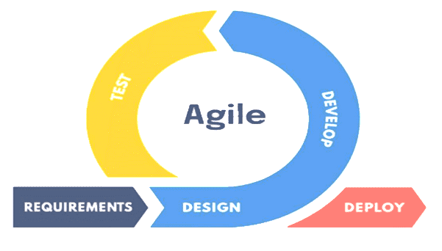

**Figure 2 – Agile Model**

For the development of the Skiller: Intelligent Computer-assisted Instruction System, we will adopt the Agile model due to its comprehensive approach that combines data gathering procedures and development phases. This approach will ensure that the system is built to meet the evolving needs of both educators and learners.

**Requirements Gathering.** During the initial planning phase, the research team deliberated various aspects concerning the study and the forthcoming system development. Discussions encompassed the systematic execution of the study, including the structure of future meetings, communication protocols among team members, and anticipation of potential outcomes for each action. Task allocation involved distinct roles: the research team focused on data collection through online surveys (see Appendix B), interviews, document analysis, and review, while the programming team delved into the process of designing, writing, testing, debugging, and maintaining the system's source code. A designated designer concentrated on assessing the feasibility of a conceptual design, incorporating technical specifications, defining system architecture, modules, interfaces, and data to meet specified requirements. Throughout the research, insights were garnered by examining existing systems related to the study, providing valuable input on data storage, management, and presentation. Additionally, the researchers scrutinized the project's planning and initiation steps, establishing a clear timeline for the project's development. (see Appendix A )

**Design**. The progress of the study was initiated by gathering the information and data needed while team members applied their knowledge in selected IT skills. Several software was required as a support in the development of the system, heavily relying on php coding, manipulation of database, interface designs, and documentations which will be mainly done in a computer unit. Upon acquiring all data, the researchers will proceed to meet the project goal, strictly undergoing the phases of agile methodology. The product of these steps will be the finished system aimed for the SSC-R de Cavite SHS Department

|  |  |  |  |
| --- | --- | --- | --- |
| **USER** | **INPUT** | **PROCESS** | **OUTPUT** |
| Admin | Email, Password, Personal Information, Student, Faculty, Subjects. and Site Settings | Login, Logout, Modify Account, Manage Subject, Manage Faculty, and Manage Student | Account details, Assigned Faculty, Assigned Subjects, Assigned Students |
| Faculty | Email, Password, Personal Information, Lectures, Quizzes | Create Account, Modify Account, Login Logout, Manage Lectures, and Manage Quizzes | Account Details, Lectures, Quizzes, and Students Progress |
| Student | Email, Password, Personal Information, Quizzes | Create Account, Modify Account, Login Logout, Answer Quizzes | Account Details, Subject Information, Scores, and Quizzes List |

The system requires users to input email, password, and personal information for storage in the database. The administrator manages logins, modifies accounts, subjects, and the site. Outputs include account details, faculty-subject assignments, and student information. Faculty users create accounts, manage lectures, and quizzes. Outputs include account details, lecture lists, quizzes, and student progress. Students create accounts, modify their info, and answer quizzes. Outputs include account details, subject info, scores, and quiz lists.

**FIGURE 3. Input-Process-Output (IPO) of Skiller: Intelligent Computer-assisted Instruction System**

**Develop.** Gathering of data about SHS Department Online Learning and other related study will be done to measure information on variable of interest, suggestions and recommendations that will enable the researchers to answer the research questions, hypothesis and evaluate outcomes about the proposed system. This will be a big help to obtain detailed information, suggestions and recommendation for the system. Once all the required information is at hand, the programmer will proceed to the backend coding to insert functions within the system until a prototype is done.

**Test**. A UAT survey will be conducted in order to evaluate the developed system utilizing the Likert Scale, a type of rating scale used to measure respondents’ level of agreement with the given statement or question (Bertram, 2016). With this scale, respondents will be asked to rate items on a level of agreement regarding the system’s functionality, reliability, usability, efficiency and maintainability. (See Appendix D)

**Deploy**. Deploying an Intelligent Computer-assisted Instruction System involves a series of crucial steps to ensure a seamless transition from the developmental stage to a live, accessible platform. Additionally, it's essential to provide comprehensive user guides and documentation for both students and educators, documenting technical aspects for future maintenance and development. Following these steps ensures a well-planned and executed deployment of the Intelligent Computer-assisted Instruction System. In the maintenance point, guaranteeing the continuous functionality of the Intelligent Computer-assisted Instruction System and mitigating the risk of data loss are pivotal. A recommended approach involves scheduling regular automatic backups, including the database, on a daily basis. Securely storing these copies off-site is crucial to safeguard against potential server failures or disasters.

1. **Development Tools**

Development tools play a crucial role in shaping the functionality and design of Skiller: Intelligent Computer-assisted Instruction System, empowering developers to create dynamic and effective platforms for educational engagement.

Table 1 – Hardware

|  |  |
| --- | --- |
| I/O Device | Monitor, Mouse, Keyboard, CPU |
| Processor | AMD Ryzen 5 3400g with Radeon Vega 7 |
| Motherboard | HP 838F |
| Memory | 8GB RAM |
| Hard Disk Drive | 120GB SSD / 500GB HDD |
| Auxiliaries | NVIDIA GeForce GTX 1050ti  22” FHD Asus  Intel® Wireless-AC 9560 802.11b/g/n/ac (2x2) Wi-Fi and Bluetooth 5 Combo |

Table 2 – Software

|  |  |
| --- | --- |
| Front-End Technologies | PHP, HTML, CSS, and JavaScript |
| Database | MySQL |
| Design of User Interface | Adobe Photoshop, Bootstrap 4 |
| System Documentation | Microsoft Word and Excel 2016 |
| Web Server | XAMPP, Hostinger |
| Operating System | Microsoft Windows 10 |

1. **Respondents/Evaluators**

**Respondents**. The CICT and LMS Office personnel and administrators who are in-charge of keeping, organizing, and delivering of student records and information are the respondents of the interview. While the Faculty members are the one uploading various course content. And the students will the one uses the Intelligent Computer-assisted Instruction System. This information will serve as the foundation of the system developed by the project team members.

**Evaluators.** These 4 types of user will also serve as the project’s evaluators who will test the system to be developed.

1. **Statistical Treatment of Data**

In assessing the effectiveness and impact of the "Skiller: Intelligent Computer-assisted Instruction System," various statistical methods will be applied to analyze the collected data. Two key statistical measures, Frequency Mean and Weighted Mean, will be used to derive valuable insights from the gathered data.

Formula of Percentage:

$$\frac{Number of Respondents}{Total Number of Respondents} x 100$$

Sample Size Formula:



Weighted Mean Formula:

$$X=\frac{ ∑ (w ⋅ x)}{∑ w}$$

Where: ∑= Summation

w = number of weights

x = number of values diagrams

1. **Project Schedule**

What will serve as the guide of the researchers to meet the requirements and the subject needs in due time will be the Gantt Chart (See Appendix A). Following the schedule strictly will give the team the urge to work on the project and will be given enough time should revisions occur. Progress of the study is divided into 5 phases; Requirement, Design, Development, Testing and Deployment.

Requirement phase basically consists of the discussion of team members on how the study will be done, where the researchers work on the progression of the study, etc. Assigning of the project team members’ roles will also be done in this phase as part of the planning. It this phase, researching and gathering of data will be the focus. Researchers will identify all the materials needed for the project, acquire knowledge through research and conducting thorough reviews of related literatures and studies as well as the gathering of data from the subject. This phase has a span of 1 month and 2 weeks.

Design Phase is mainly for the structural and user interface design of the system software to be developed. Diagrams and system flowcharts will be created in this phase who will act as a support material for the system software. This phase has a span of 1 month.

The Development phase marks the start of the backend coding and working functions for the system software. This phase has a span of 2 months.

From the respondents and evaluator of the research, the Testing and Deployment phase will be done by gathering feedbacks of the system software developed in the previous phase. All bugs, issues, concerns, and suggestions from the respondents will be taken into considerations.

# Chapter IV RESULTS AND DISCUSSIONS

1. **Summary of Observation in the Existing System**

The interview that was conducted to gather information and data about the Learning Management System as well as a representative from the SHS Faculty. In this study, it was important to acquire knowledge in all the processes done in LMS and the online learning experience of the students to satisfy the project goals. Through the course of the interviews, the staff had shared valuable information with the project team and issues and concerns they usually face in the office as well as the recommendations they can give to the proposed system were addressed.

1. **Existing System**

Our specialized tutorial system focuses on addressing the challenges senior high school students face in a specific subject. With distinct roles for admin, faculty, and students, it features a unique, targeted subject approach, a progressive content structure, interactive quizzes, comprehensive student management, and analytics for continuous improvement. This ensures a tailored and effective learning experience, emphasizing student engagement and personalized support.

1. **Current Problems**

The current system faces security authentication concerns and limitations in the quiz category, including the inability to add a mid-term exam. Improving security measures and expanding quiz categories, especially incorporating mid-term exams, should be prioritized for enhanced system functionality.

1. **The Proposed Project Details**

**Project Narrative Description.** The researchers’ aims to develop an innovative web-based Intelligent Computer-assisted Instruction System to revolutionize the education experience. This platform will provide a user-friendly interface for students and educators, facilitating seamless interaction and knowledge transfer. The web-based Intelligent Computer-assisted Instruction System will feature diverse learning modules, interactive content, and assessment tools to enhance engagement and understanding. Emphasizing accessibility, it will be designed to accommodate various subjects and learning styles. With a focus on fostering a dynamic and collaborative learning environment, our project seeks to empower both students and educators in the realm of online education. The system requires all the users to input their email, password, and personal information in such the system will use this data to be stored in the database, and will be used upon validating and granting the users with specific rights to the system. The administrator is allowed to login and logout, modify existing accounts for faculty and students, modify the subjects, as well as modify the site itself. Through these rights for the admin, account details, assigned faculty in each subject, assigned subjects, and students in each faculty are all available as the output of the system through the Administrator. On the other hand, the faculty is prompt to create an account, login and logout, modify its account, manage the lecture, create and manage the quizzes. Providing these data, account details, lectures list, quizzes, and student progress are all present as the output in the system through the faculty user. Lastly, the students are allowed to create an account, modify their own account, login and logout, and answer the assigned quizzes. Account details, subject details, scores, and list of quizzes are present in the student output.

**Internal Design**. The researchers designed the database structure of the system software with several tables all with their own functionalities. Each database tables contained all the required fields to input and display information. The database structure has been enhanced to deliver and process information faster in a minimal runtime as possible. In terms of each fields contained in each table, each field were given names unique enough to distinguish which fields belong to which table (See Appendix H)

**External Design**. Skiller: Intelligent Computer-assisted Instruction System were carefully designed to cover the project goals. The login screen (See appendix E).

The login page serves as the gateway to our comprehensive Tutorial management ystem, designed in the familiar structure of our school. Upon authentication, the administrator is greeted with an intuitive dashboard, consolidating information on enrolled faculty and students, accompanied by user-friendly side panels for seamless navigation.

The administrator has access to various modules, starting with the Students Management section, where the student list is displayed, and administrative actions such as editing, deleting, and deactivating accounts can be performed.

The Admin Student Form facilitates the addition of new students to the system.In the Admin Faculty section, the administrator can manage the faculty list, with capabilities to edit, change passwords, delete, and deactivate accounts. The Admin Faculty Form allows the administrator to seamlessly add new faculty members to the system. The Admin Site Settings section empowers the administrator to customize the platform by changing images and logos. Faculty members, upon logging in, are presented with a dedicated dashboard showcasing available subjects. The Faculty Subject section provides a comprehensive list of subjects where faculty can edit, attach descriptions, and upload images. The Faculty Subject Form enables faculty to modify subject details and add visual content.

Additionally, faculty can navigate the Faculty Student section to monitor students' progress, while the Faculty Lecture Management section offers a comprehensive view of topics within a specific subject, allowing faculty to edit and add quizzes. The Faculty Edit Lecture Management interface provides a platform for fine-tuning lecture details and uploading relevant files.

For quiz creation, the Faculty Quiz section allows faculty to craft quizzes with a question and four possible answers. Students can access their profiles, update email information, and view certificates through the Student Profile interface. The Student Interface section displays subjects and student progress, while the Student Quiz area lists available quizzes. Post-quiz, the Student Score Interface showcases the student's performance.

**Modules and Functions**

**Login.** Simply for authenticating users before given access to the system by asking for a email and password (See appendix E.).

**Student Management** the process of modifying and adding students, update, deactivate and reset password

**Faculty Management** the process of modifying and adding students, update, deactivate and reset password

**Subject Management** the subject managements allows admib to create subject and assigned faculty to manage the specific subject

**Create Lecture**  the process of developing and organizing a presentation or speech intended for educational or informational purposes.

**Progress** positive movement toward a goal or improvement. It indicates advancement, development, or the achievement of objectives over time. Progress can be measured in various aspects of life, such as personal growth, technological advancements, societal changes, or project accomplishments.

**Quiz** is a short test or examination designed to assess knowledge, skills, or understanding, often on a specific topic.

**Profile** allows student modify picture profile, to view their information such as id ,name, email and their downloadable certificate.

1. **Implementation Issues**

**Hardware and Software Requirements.** Skiller: Intelligent Computer-assisted Instruction System’s system software hardware requirements were solely based on the minimum hardware specification to run mySQL workbench smoothly and mySQL servers.

Table 3 – Hardware and Software Requirements

|  |  |
| --- | --- |
| Hardware Requirements | |
| CPU | Intel Core or Xeon 3GHz (or Dual Core 2GHz) or equal AMD CPU |
| Core | Single (Dual/Quad Core is recommended) |
| RAM | 4 GB (6GB Recommended) |
| Graphic Accelerators | nVidia or ATI with support of OpenGL 1.5 or higher |
| Display Resolution | 1366x768 screen resolution monitor |
| Software Requirements | |
| Browser | Google Chrome |
| Database Server | mySQL Server Workbench 8.0 CE (Recommended) |
| Operating System | At least windows 7 or higher |

**Security**. Skiller: Intelligent Computer-assisted Instruction System has a built-in admin authorization, asking for admin login and password before the full functionality of the system is accessed. In case of users who try to access a certain page via manual input of the URL, a validation occurs before reaching the page.

**Training and Maintenance.** The system software developed by the researchers requires minimal training. Faculties and Students who will primarily use the website only needed to be familiarized in the functionalities of the system software, especially the buttons displayed on the screen. While the CICT and LMS staff who will maintain and the administrative use the website will needs more training and guidance in using the system. A system manual will be provided and can be accessed through the system software itself together with a hardcopy of it.

**Other Relevant Issues.** Due to confidentiality of information, especially in getting student data from SSC-R de Cavite ’s Registrar office, inputting student data to the proposed system could be a problem as well as the faculty loading issued by the VP for Academics department.

1. **Results of User Acceptance Test (UAT)**

**Students**

The feedback indicates that a significant majority of evaluators (69%) find the system to perform accurate and seamless intelligent computer-assisted instructions. Additionally, 30% rated it at a level of 3, suggesting a generally positive perception of the system's performance. Only a small percentage (1%) rated it a 2, indicating minor issues, and none gave it the lowest rating (1). Overall, the feedback suggests a high level of satisfaction with the system's accuracy and seamless functionality in providing computer-assisted instructions.

The majority of evaluators (99%) find the system intuitive and user-friendly, with 54% rating it a 3 and 45% rating it a 4 on the scale. Only 2% find it less user-friendly (rated 2), and none rated it the lowest (1). Overall, positive feedback on usability.

the performance consistency of "Skiller" across different web browsers and devices is generally positive. Half of the evaluators (50%) gave it the highest rating (4), indicating that the system performs consistently well across various browsers and devices. Additionally, 38% rated it a 3, suggesting a reasonably consistent performance. A small percentage (4%) rated it a 2, indicating some issues with consistency, and none gave it the lowest rating (1).

significant majority of evaluators (67%) find that the system generates complete and timely reports related to intelligent computer-assisted instructions. Additionally, 32% rated it at a level of 4, indicating a high level of satisfaction with the completeness and timeliness of the reports. Only a small percentage (1%) rated it a 2, suggesting minor issues with completeness or timeliness, and none gave it the lowest rating (1).

a significant majority of evaluators (67%) find that the system is cross-platform compatible, meaning it works well across different screen resolutions, browsers, and operating systems. Additionally, 32% rated it at a level of 4, indicating a high level of satisfaction with its cross-platform compatibility. Only a small percentage (1%) rated it a 2, suggesting minor issues with compatibility, and none gave it the lowest rating (1).

that a significant portion of evaluators (40%) acknowledges that Skiller, as an eLearning platform, implements robust security measures to protect the personal information of students. Another 40% rated it at a level of 3, indicating a moderately positive perception of the security measures in place. A smaller percentage (20%) rated it a 2, suggesting some concerns with security implementation, and none gave it the lowest rating (1).

the significant majority of evaluators (55%) find the system easily accessible and stable, even when performing simultaneous or multi-tasks. Additionally, 45% rated it at a level of 4, suggesting a high level of satisfaction with the system's accessibility and stability during multitasking. Importantly, none of the evaluators gave it the lowest rating (1), and none expressed concerns at the second-lowest rating (2).

54% rating of 4 suggests that a majority of users find the system to be accessible with ease, exhibiting both speed and efficiency. This indicates that a significant portion of users perceives the system as optimized for multiple tasks or functions. 46% rating of 3 implies that a substantial number of users consider the system to be satisfactory in terms of accessibility and efficiency. While not as strong as the rating of 4, a rating of 3 still suggests a positive overall experience.

**Faculty**

The feedback indicates a strong positive response regarding the overall functionality of "Skiller" for faculty tasks, such as content uploading and grading. The majority of evaluators (75%) gave it the highest rating (4), indicating a high level of satisfaction with the system's functionality. Another 25% rated it at a level of 3, suggesting a positive but slightly less emphatic perception. Importantly, none of the evaluators rated it at the lower levels (2 or 1).

it suggests that 75% of faculty members find the system to be intuitive, user-friendly, and with an interface that has elements that are easy to access (rated 3). Additionally, 25% of faculty members provided the highest rating (4), indicating that a quarter of them perceive the system as highly intuitive and user-friendly. Importantly, none of the faculty members rated it at the lower levels (2 or 1), suggesting that none of them found significant issues with the system's usability.

The feedback suggests that all evaluators (100%) find the system accessible with ease, both in terms of speed and efficiency, for multiple tasks or functions, as they rated it at level 3. There were no ratings for the highest level (4), and none of the evaluators rated it at the lower levels (2 or 1), indicating that none of them found significant issues with the system's accessibility.

The feedback suggests that all evaluators (100%) are highly positive about the system's ability to generate complete and timely reports related to intelligent computer-assisted instructions, as they all rated it at the highest level (4). There were no ratings for the lower levels (3, 2, or 1), indicating unanimous satisfaction with the system's performance in generating comprehensive and timely reports.

The feedback indicates that a significant majority of evaluators (75%) find the system to be highly cross-platform compatible, meaning it works well across various screen resolutions, browsers, and operating systems, as they rated it at level 4. Additionally, 25% of evaluators provided a rating of 3, suggesting a positive view of its cross-platform compatibility. Importantly, none of the evaluators rated it at the lower levels (2 or 1), indicating that none of them found significant issues with the system's cross-platform compatibility.

The feedback indicates that 75% of evaluators find "Skiller" as an eLearning support to be accessible from different devices, as they rated it at level 3. Additionally, 25% of evaluators provided the highest rating (4), indicating that a quarter of them perceive "Skiller" as highly accessible from different devices. Importantly, none of the evaluators rated it at the lower levels (2 or 1), suggesting that none of them found significant issues with accessibility from different devices.

The feedback suggests that there is a balanced perspective on the consistency of "Skiller" in providing accurate and reliable data regarding student performance and engagement. Half of the evaluators (50%) rated it at level 4, indicating a high level of satisfaction with the accuracy and reliability of the data. Another 50% of evaluators provided a rating of 3, suggesting a positive view but perhaps not as emphatic.

The feedback suggests that 75% of evaluators find the system accessible with ease, both in terms of speed and efficiency for multiple tasks or functions, as they rated it at level 4. Additionally, 25% of evaluators provided a rating of 3, suggesting a positive but slightly less emphatic view.

**Admin**

The feedback indicates that all evaluators (100%) believe that "Skiller" as an eLearning platform allows administrators to manage effectively, as they rated it at the highest level (4). There are no ratings for the lower levels (3, 2, or 1), suggesting unanimous satisfaction with the system's capability for administrators to manage tasks.

The feedback indicates that all evaluators (100%) find the system to be intuitive, user-friendly, with an interface that has elements that are easy to access, as they rated it at level 3. There are no ratings for the highest level (4) or the lower levels (2 or 1), suggesting unanimous satisfaction with the system's usability and user-friendly interface, albeit not rated at the highest level.

The feedback indicates that all evaluators (100%) believe that "Skiller" as an eLearning platform implements security measures to protect the personal information of students, as they rated it at level 3. There are no ratings for the highest level (4) or the lower levels (2 or 1), suggesting unanimous satisfaction with the system's implementation of security measures to safeguard personal information.

The feedback indicates that all evaluators (100%) find the system easily accessible and stable, even when performing simultaneous or multi-tasks, as they rated it at level 3. There are no ratings for the highest level (4) or the lower levels (2 or 1), suggesting unanimous satisfaction with the system's accessibility and stability, particularly during simultaneous or multi-tasking activities.

The feedback indicates that all evaluators (100%) believe that the system is cross-platform compatible, meaning it works well across various screen resolutions, browsers, and operating systems, as they rated it at the highest level (4). There are no ratings for the lower levels (3, 2, or 1), suggesting unanimous satisfaction with the system's compatibility across different platforms.

The feedback suggests that all evaluators (100%) believe that the system can be restored or repaired to a defined condition within a specified period when maintenance is performed in accordance with prescribed procedures, as they rated it at level 3. There are no ratings for the highest level (4) or the lower levels (2 or 1), indicating unanimous confidence among evaluators in the system's ability to be restored or repaired effectively during maintenance.

The feedback suggests that all evaluators (100%) believe that the system performs consistently according to its specifications, as they rated it at the highest level (4). There are no ratings for the lower levels (3, 2, or 1), indicating unanimous confidence among evaluators in the system's ability to consistently meet its specifications.

The feedback indicates that all evaluators (100%) find the system accessible with ease, both in terms of speed and efficiency for multiple tasks or functions, as they rated it at level 3. There are no ratings for the highest level (4) or the lower levels (2 or 1), suggesting unanimous satisfaction with the system's accessibility and efficiency, particularly for handling multiple tasks or functions.

The feedback indicates that all evaluators (100%) believe that "Skiller" as an eLearning support allows access from different devices, as they rated it at the highest level (4). There are no ratings for the lower levels (3, 2, or 1), suggesting unanimous confidence among evaluators in the system's ability to support access from various devices.

**IT EXPERT**

The feedback suggests that all evaluators (100%) believe that "Skiller" as an eLearning platform allows administrators to manage students and faculty effectively, as they rated it at the highest level (4). There are no ratings for the lower levels (3, 2, or 1), indicating unanimous confidence among evaluators in the system's capability for administrators to manage students and faculty.

The feedback indicates that all evaluators (100%) believe that the system is intuitive, user-friendly, with an interface that has elements that are easy to access, as they rated it at the highest level (4). There are no ratings for the lower levels (3, 2, or 1), suggesting unanimous confidence among evaluators in the system's ease of use and user-friendly design.

The feedback suggests that all evaluators (100%) believe that the system is accessible with ease, both in terms of speed and efficiency for multiple tasks or functions, as they rated it at level 3. There are no ratings for the highest level (4) or the lower levels (2 or 1), indicating unanimous satisfaction among evaluators with the system's accessibility and efficiency, particularly for handling multiple tasks or functions.

The feedback indicates that all evaluators (100%) believe that the system is easily accessible and stable, even when performing simultaneous or multi-tasks, as they rated it at level 3. There are no ratings for the highest level (4) or the lower levels (2 or 1), suggesting unanimous satisfaction among evaluators with the system's accessibility and stability, particularly during simultaneous or multi-tasking activities.

The feedback indicates that all evaluators (100%) believe that the system is cross-platform compatible, meaning it works well across various screen resolutions, browsers, and operating systems, as they rated it at level 3. There are no ratings for the highest level (4) or the lower levels (2 or 1), suggesting unanimous satisfaction among evaluators with the system's compatibility across different platforms.

The feedback indicates that all evaluators (100%) believe that "Skiller" as an eLearning platform implements security measures to protect the personal information of students, as they rated it at level 3. There are no ratings for the highest level (4) or the lower levels (2 or 1), suggesting unanimous satisfaction among evaluators with the system's implementation of security measures to safeguard personal information.

The feedback suggests that all evaluators (100%) believe that the system consistently performs according to its specifications, as they rated it at the highest level (4). There are no ratings for the lower levels (3, 2, or 1), indicating unanimous confidence among evaluators in the system's ability to consistently meet its specifications.

The feedback suggests that all evaluators (100%) believe that the system is accessible with ease, both in terms of speed and efficiency for multiple tasks or functions, as they rated it at level 3. There are no ratings for the highest level (4) or the lower levels (2 or 1), indicating unanimous satisfaction among evaluators with the system's accessibility and efficiency, particularly for handling multiple tasks or functions.

The feedback indicates that all evaluators (100%) believe that "Skiller" as an eLearning support allows access from different devices, as they rated it at the highest level (4). There are no ratings for the lower levels (3, 2, or 1), suggesting unanimous confidence among evaluators in the system's ability to support access from various devices.

After conducting the process implemented in this study, the team was able to gather the result of the User Acceptance Test (UAT).

|  |  |  |  |  |  |  |  |
| --- | --- | --- | --- | --- | --- | --- | --- |
| Criteria | Students | Faculty | Admin | I.T Expert | Composite Mean | Verbal Interpretation | Rank |
|  |  |  |  |  |  |  |  |
| Functionality | 3.48 | 3.75 | 4.00 | 4.00 | 3.81 | **AGREE** | 1 |
| Reliability | 3.45 | 3.50 | 3.50 | 3.50 | 3.49 | **AGREE** | 4 |
| Usability | 3.50 | 3.50 | 3.50 | 3.50 | 3.50 | **AGREE** | 3 |
| Efficiency | 3.54 | 3.75 | 3.00 | 3.00 | 3.32 | **AGREE** | 5 |
| Maintainability | 3.54 | N/A | 3.00 | 3.00 | 3.18 | **AGREE** | 6 |
| Security | 3.54 | 3.00 | 3.00 | 3.00 | 3.13 | **AGREE** | 7 |
| Compatibility | 3.19 | 3.25 | 4.00 | 4.00 | 3.61 | **AGREE** | 2 |
| OVERALL COMPOSITE MEAN |  | | | | **3.44** | **AGREE** |  |

**Figure 27. Students, Faculty, Admin, and  IT Expert Responses**

The table presents the gathered data that the team has conducted upon applying a User Acceptance Test to the Students, Faculty, Admin, and IT Experts as respondents.  This test has been conducted to analyze and represent the effectiveness of General Mathematics Learning for SHS Students. Hence, in terms of Functionality, the system gathered a total of 3.81 composite mean, having also the highest rank out of all the 7 criteria given. Followed by the next leading criteria, the compatibility. The respondents agreed that the system is capable enough in terms of all the constraints that had been given during the test, which received a total of 3.61 composite

mean. In terms of usability, the respondents agreed as it accepts a total of 3.50 for its composite mean making it as the third highest and best criteria that the app contains. The respondents agreed that the app is reliable enough giving it a total of 3.49 of composite mean. On the other hand, the system’s efficiency got 3.32 for its composite mean, followed by the maintainability, having a total of 3.18. Finally, the respondents believed that the security of the system deserved to receive a total of 3.13 for its composite mean. Given us the overall composite mean of 3.44.

1. **Benefits of the Proposed System**

The proposed online learning platform aims to enhance the learning experience by providing convenient 24/7 access to materials, breaking geographical barriers, and fostering flexible study schedules. Its interactive environment, featuring engaging multimedia content and gamification, promotes dynamic learning. The system supports personalized learning, with diverse modules covering various subjects and real-time feedback, fostering collaboration and communication. It contributes to efficiency by reducing resource reliance and commute time, while a commitment to continuous improvement ensures adaptability to emerging trends, positively impacting both students and educators.

The table presents the gathered data that the team has conducted upon applying a User Acceptance Test to the Students, Faculty, Admin, and IT Experts as respondents. This test has been conducted to analyze and represent the effectiveness of Skiller. Hence, in terms of Functionality, the system gathered a total of 3.44 composite mean, having also the highest rank out of all the 7 criteria given. Followed by the next leading criteria, the compatibility. The respondents agreed that the system is capable enough in terms of all the constraints that had been given during the test, which received a total of 3.61 composite mean. In terms of usability, the respondents agreed as it accepts a total of 3.50 for its composite mean making it as the third highest and best criteria that the app contains. The respondents agreed that the app is reliable enough giving it a total of 3.49 of composite mean. On the other hand, the system’s efficiency got 3.32 for its composite mean, followed by the maintainability, having a total of 3.18. Finally, the respondents believed that the security of the system deserved to receive a total of 3.13 for its composite mean.

**Chapter V**

**SUMMARY, CONCLUSION AND RECOMMENDATION**

The results of the UAT conducted by the researchers were overwhelmingly positive. This may serve as a justification that the implementation for the project proposed in this research is highly recommended.

Additionally, the researchers recommends future researchers to utilize the data contained in this research document to help future enhancements and to conduct different methods and tools that may produce new ideas.

The researchers also recommend future developers to contribute and improve the system in terms of: (1) Implementing automatic database backup for security purposes; (2) Better deployment that would release the system software in the Internet and at the same time be used by the other campuses; (3) Enhance student engagement by incorporating quizzes, multimedia content, and gamification features. Optimize the website for mobile devices to provide seamless access across various platforms. Prioritize a user-friendly interface and intuitive navigation, fostering an improved overall user experience for both students and educators., (4)Utilize an advanced learning methods.

# REFERENCES

*EdModo Social Learning Platform - Learning Platforms.* (2015, August 13). a secure social network platform with the functionalities of a learning management system (LMS)Learning Platforms. <https://www.learningplatforms.net/edmodo/>

*NEO: Simple, Powerful LMS for schools and Universities.* (n.d.-b). <https://www.neolms.com/portal_search>

*TalentLMS: the #1 cloud LMS software for online learning.* (2023, October 18). a highly configurable cloud-hosted learning management system created to help users simplify how they facilitate online seminars, courses, and other training programTalentLMS.[https://www.talentlms.com/aff:adwords?utm_source=google&utm_medium=cpc&utm_campaign=tabreplus&utm_term=talentlms&matchtype=e&network=g&keyword=talentlms&device=c&cid=1947306673&grpid=71102659352&gad_source=1&gclid=CjwKCAiAjfyqBhAsEiwA-UdzJN9Ae_3MyxepdIsrNluuyIoQBvQT7lEG1OpqskEFAgX1xFV3D0q-XhoCmJEQAvD_Bw E](https://www.talentlms.com/aff:adwords?utm_source=google&utm_medium=cpc&utm_campaign=tabreplus&utm_term=talentlms&matchtype=e&network=g&keyword=talentlms&device=c&cid=1947306673&grpid=71102659352&gad_source=1&gclid=CjwKCAiAjfyqBhAsEiwA-UdzJN9Ae_3MyxepdIsrNluuyIoQBvQT7lEG1OpqskEFAgX1xFV3D0q-XhoCmJEQAvD_BwE)

*Moodle provides information about the platform's features*. Moodle is a free, web-based Learning Management System that empowers educators to develop personalized websites containing interactive courses, promoting learning at any location and time. Whether you're a teacher, student, or administrator, Moodle is adaptable to your requirements. The highly customizable core of Moodle includes numerous features, as detailed in the documentation at https://docs.moodle.org/en/Features.

**APPENDICES**

**Appendix A**

### Gantt Chart

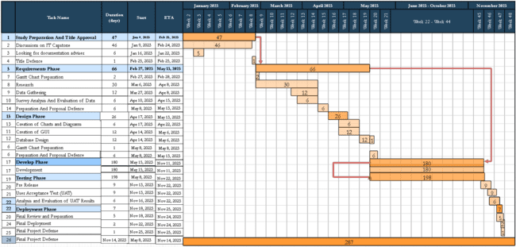

## Appendix B

### Survey Result - Data Gathering

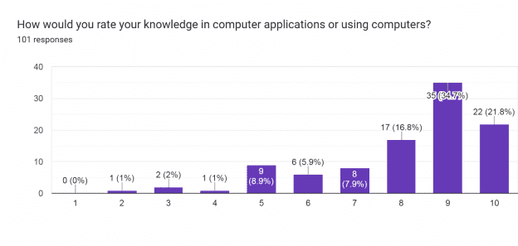

According to the survey, respondents' self-rated computer application knowledge varies. With 30.7% and 21.8%, respectively, the majority of responses are 9 or 10, which indicates a high level of trust in one's knowledge of computers. Furthermore, a sizable portion (21.8%) evaluates their level of knowledge as an 8. Less people give themselves a lower rating—11.9% at 7—and the ratings for 6 (2%), 5 (5%), 4 (1%), 3 (1%), and 1 (2%), decisively decline.

Question 1 result

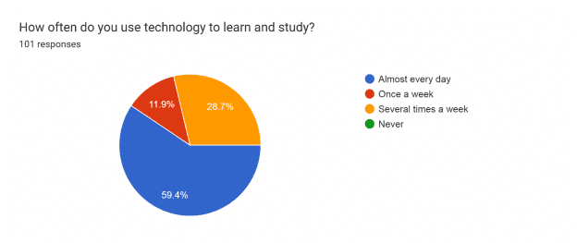

The survey highlights a strong inclination towards using technology for learning and studying among respondents. A significant majority, 59.4%, reported using technology almost every day for educational purposes. Additionally, 28.7% use technology several times a week, showing a consistent reliance on tech for learning. A smaller percentage, 11.9%, reported using technology once a week for studying, while none of the respondents indicated never using technology for learning.

Question 2 result

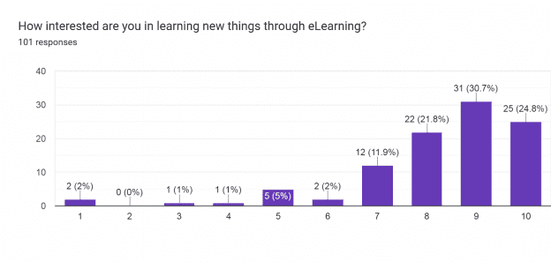

The survey reveals a strong enthusiasm for eLearning among respondents, with a considerable majority expressing high interest. Notably, 30.7% rated their interest at 9, while 24.8% rated it at 10, indicating a substantial eagerness to explore new things through eLearning. Moreover, 21.8% rated their interest at 8, showing continued enthusiasm. Smaller percentages indicated slightly lower interest levels, with 11.9% at 7, and decreasing percentages for ratings of 6 (2%), 5 (5%), 4 (1%), 3 (1%), and 1 (2%). Overall, the majority exhibit a keen interest in learning through eLearning platforms

Question 3 result

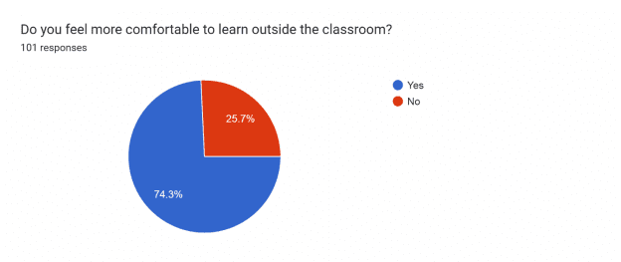

*The survey indicates a significant preference for learning outside the classroom among respondents. A vast majority, 74.3%, feel more comfortable learning in settings beyond the traditional classroom environment. Conversely, 25.7% expressed a preference for learning within the classroom setting.*

Question 4 result

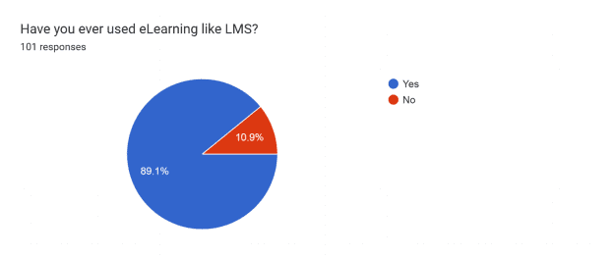

The survey findings demonstrate a widespread usage of eLearning platforms, particularly Learning Management Systems (LMS), among respondents. An overwhelming 89.1% confirmed their utilization of eLearning platforms like LMS. Conversely, a smaller proportion of 10.9% reported not having used eLearning systems.

For the 2nd section focus on student’s CLASSROOM E- LEARNING through the Learning Management Systems (LMS),

Question 5 result

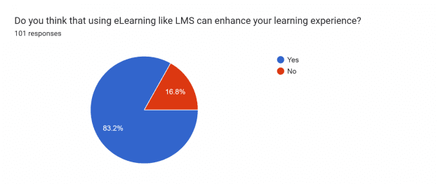

The survey highlights a strong belief among respondents in the potential of eLearning, particularly Learning Management Systems (LMS), to enhance their learning experiences. A significant majority, 83.2%, believe that using eLearning tools like LMS can positively impact their learning journey. Conversely, a smaller percentage, 16.8%, expressed skepticism about the enhancement of their learning experience through eLearning platforms.

Question 6 result

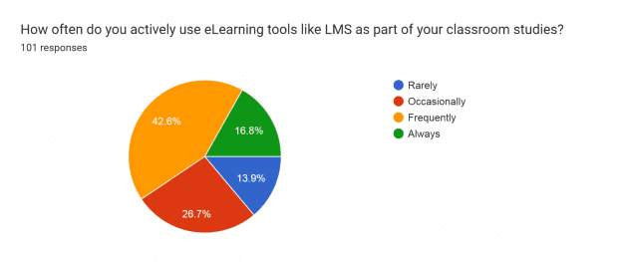

Question 7 result

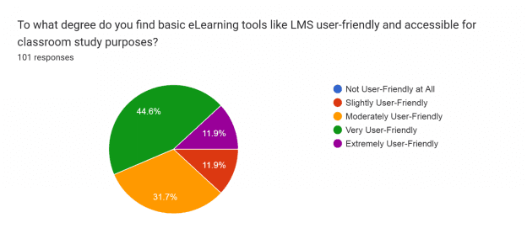

The survey findings highlight a positive perception of user-friendliness and accessibility among respondents regarding basic eLearning tools like Learning Management Systems (LMS) for classroom study purposes. A significant majority, 44.6%, regard these tools as very user-friendly, indicating a high level of ease in navigation and use. Additionally, 31.7% find them moderately user-friendly, suggesting a generally positive experience. Moreover, 11.9% perceive these tools as extremely user-friendly, while an equal percentage of 11.9% find them slightly user-friendly. Notably, none of the respondents considered these tools not user-friendly at all, indicating an overall positive evaluation of their usability for classroom study purposes.

Question 8 result

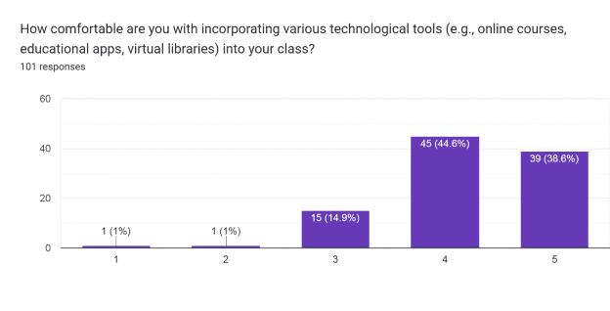

The survey shows a high level of comfort among respondents in integrating various technological tools, such as online courses, educational apps, and virtual libraries, into their classes. A significant majority, 38.6%, rated themselves at the highest comfort level of 5, indicating a strong confidence in incorporating these tools. Additionally, 44.6% rated their comfort at level 4, reflecting a substantial comfort level. Smaller percentages rated themselves at lower comfort levels, with 14.9% at level 3, and minimal representation at levels 2 (1%) and 1 (1%). Overall, the majority express a high comfort level in integrating diverse technological tools into their classroom activities.

For the 3rdsection focus on FEASIBILITY of the study Intelligence Computer Assisted Instruction (ICAI).

Question 9 result

The survey demonstrates a considerable interest among respondents in using technology and Intelligence Computer Assisted Instruction (ICAI) platforms for regular learning. Notably, significant portions rated their interest at the higher levels, with 27.7% at 9 and 25.7% at 10, indicating a strong desire for regular use of these platforms. Additionally, 24.8% expressed an interest level of 8, further highlighting a substantial inclination toward utilizing ICAI platforms. Smaller percentages indicated varying degrees of interest, with 5.9% at 7, and decreasing percentages for levels 6 (5%), 5 (8.9%), 3 (1%), and 1 (1%). There were no respondents who rated their interest at levels 4 or 2. Overall, there's a prevalent enthusiasm for incorporating technology and ICAI platforms into regular learning routines.

Question 10 result

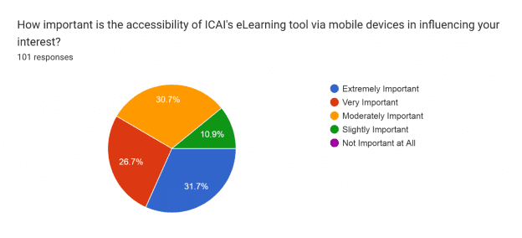

The survey findings emphasize the significance of mobile accessibility for Intelligence Computer Assisted Instruction (ICAI) eLearning tools in influencing respondents' interest. A substantial portion, 31.7%, deems mobile accessibility extremely important, indicating a high priority placed on the ability to access these tools via mobile devices. Additionally, 26.7% consider it very important, signifying a strong emphasis on mobile accessibility. Moreover, 30.7% rate it as moderately important, reflecting a notable consideration for mobile access. A smaller percentage, 10.9%, finds it slightly important, while none of the respondents consider mobile accessibility not important at all. Overall, the majority highlight the crucial role of mobile access in influencing their interest in ICAI eLearning tools.

Question 11 result

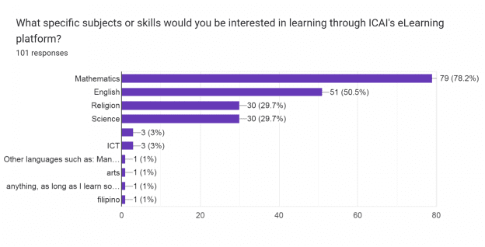

The survey indicates a strong interest among respondents in utilizing Intelligence Computer Assisted Instruction (ICAI) eLearning tools for various subjects and skills. Mathematics emerges as the most sought-after subject, with 78.2% expressing a keen interest in learning it through ICAI's eLearning platform. English follows closely behind, with 50.5% of respondents interested in using the platform for language learning. Additionally, subjects like Religion and Science garner interest from 29.7% of respondents each. A smaller percentage expressed interest in ICT (Information and Communications Technology) at 3%, Filipino at 1%, and 1% expressed interest in other subjects not specified in the survey. Overall, Mathematics and English stand out as the primary subjects of interest for utilizing ICAI's eLearning tool, followed by Religion and Science.

Overall, the survey underscores the importance of technology in education, showcasing students' readiness to embrace and leverage eLearning tools. The findings provide valuable insights for educators and institutions aiming to optimize the use of technology-driven learning methods for enhanced student engagement, improved learning outcomes, and overall educational effectiveness.The survey conducted to assess the impact of Skiller - Intelligence Computer Assisted Instruction (ICAI) on educational outcomes provides valuable insights into student perceptions and preferences regarding technology-driven learning tools. The study explores various facets, including students' self-efficacy regarding technology, their engagement with eLearning tools like Learning Management Systems (LMS), and the feasibility of incorporating Intelligence Computer Assisted Instruction (ICAI) into their educational journey.

For the 1st section focus on student’s SELF – EFFICACY about the application of technology in their leaning habits.

## Appendix C

## 

### Use case Diagram

### Appendix D

### USER ACCEPTANCE TEST UAT(QUESTIONAIRE)

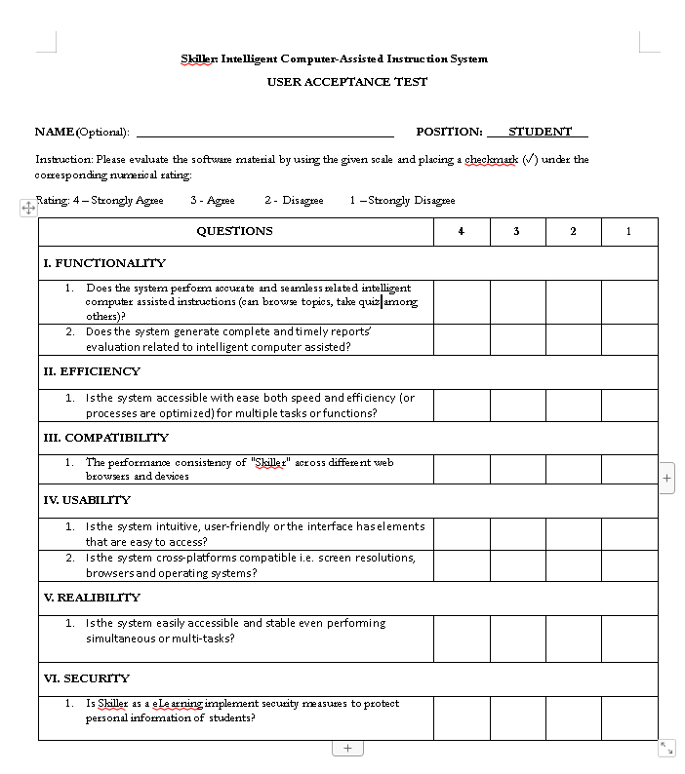

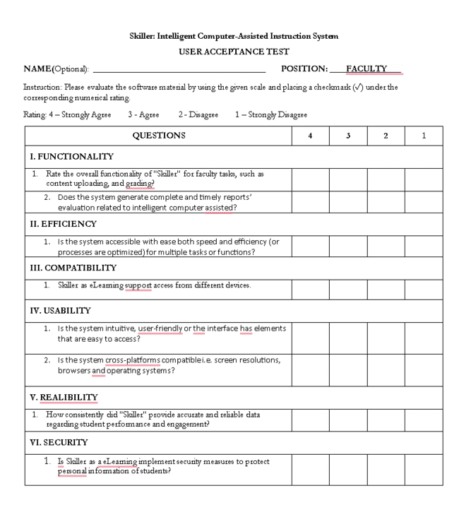

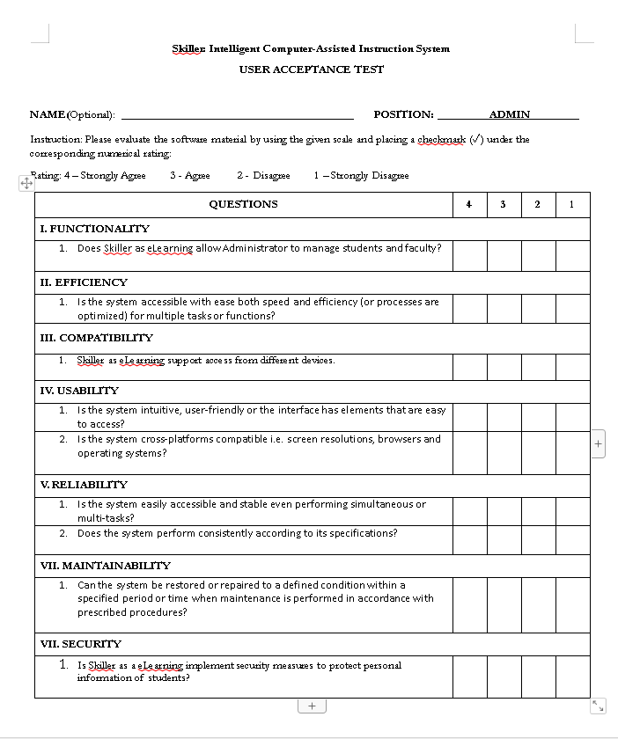

## 

## 

## Appendix E

**Sample Screenshots**

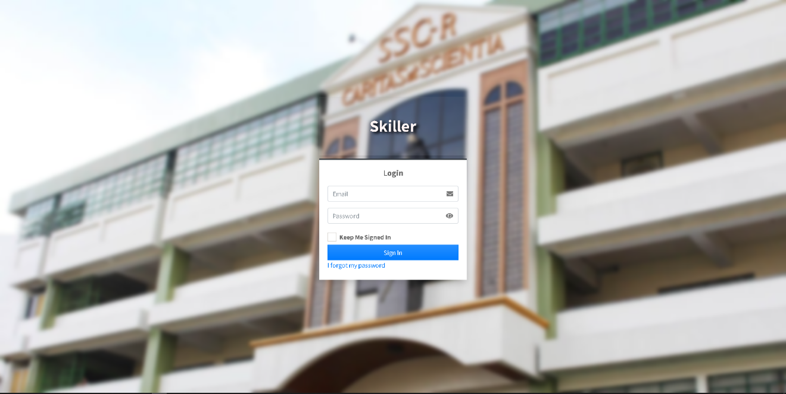

**Figure 4. Login**

*ADMIN*

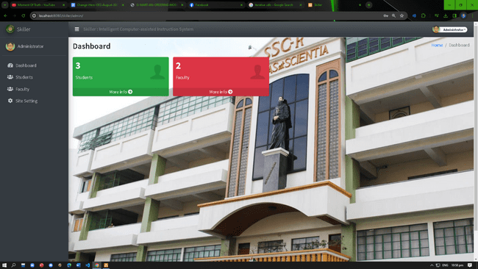

**Figure 5. Admin Dashboard**

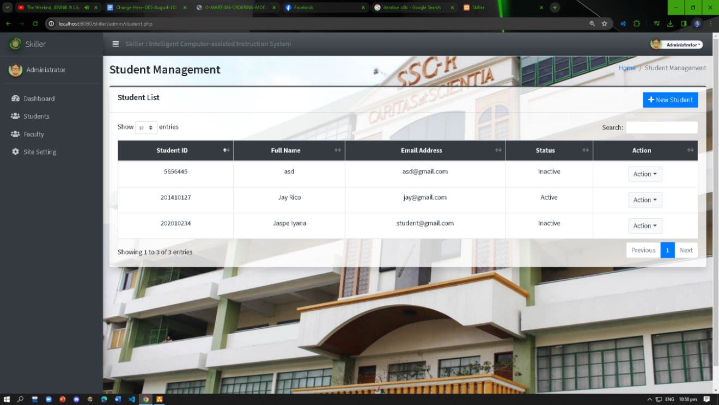

**Figure 6. Students Managent**

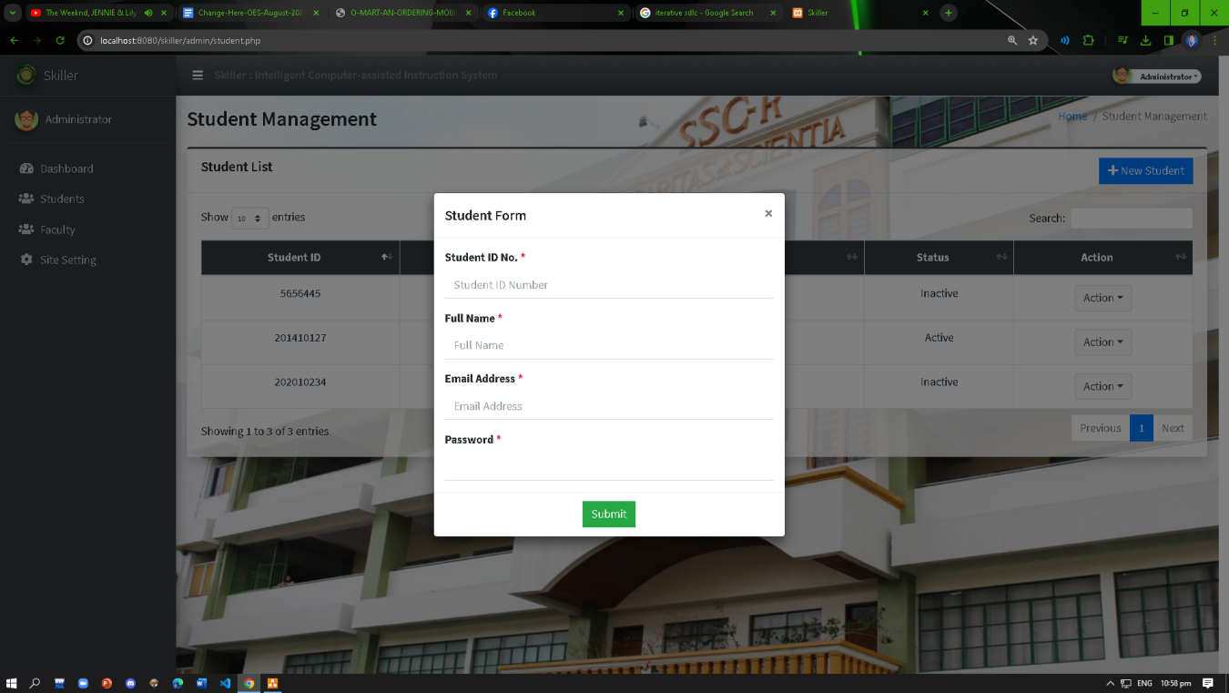

**Figure 7. Admin Student Form**

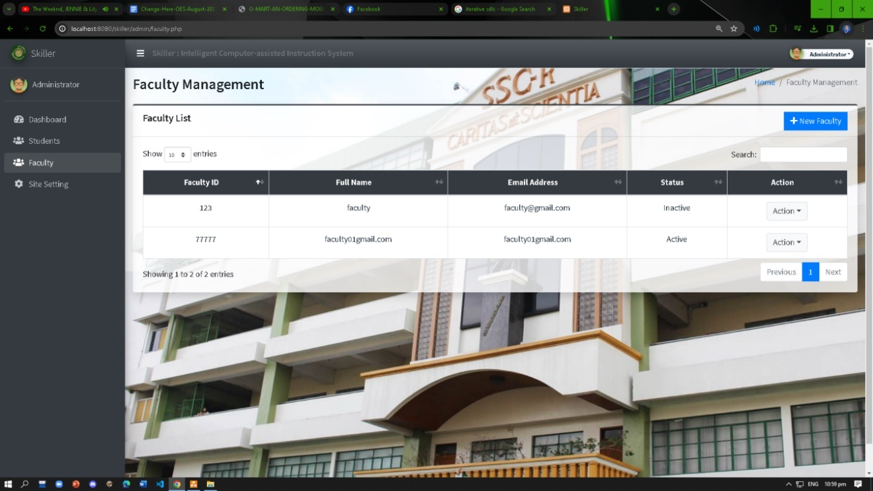

**Figure 8. Admin Faculty**

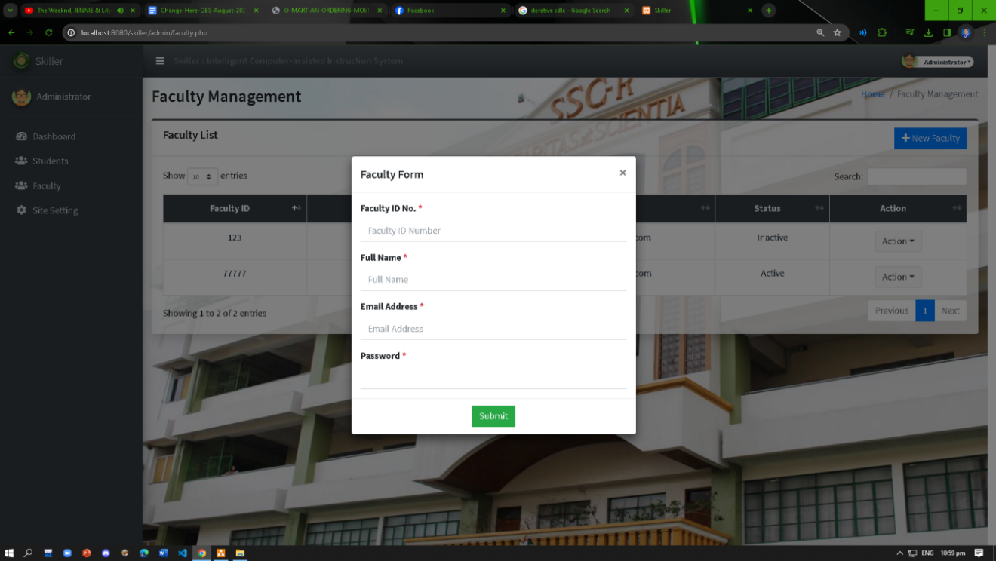

**Figure 9. Admin Faculty Form**

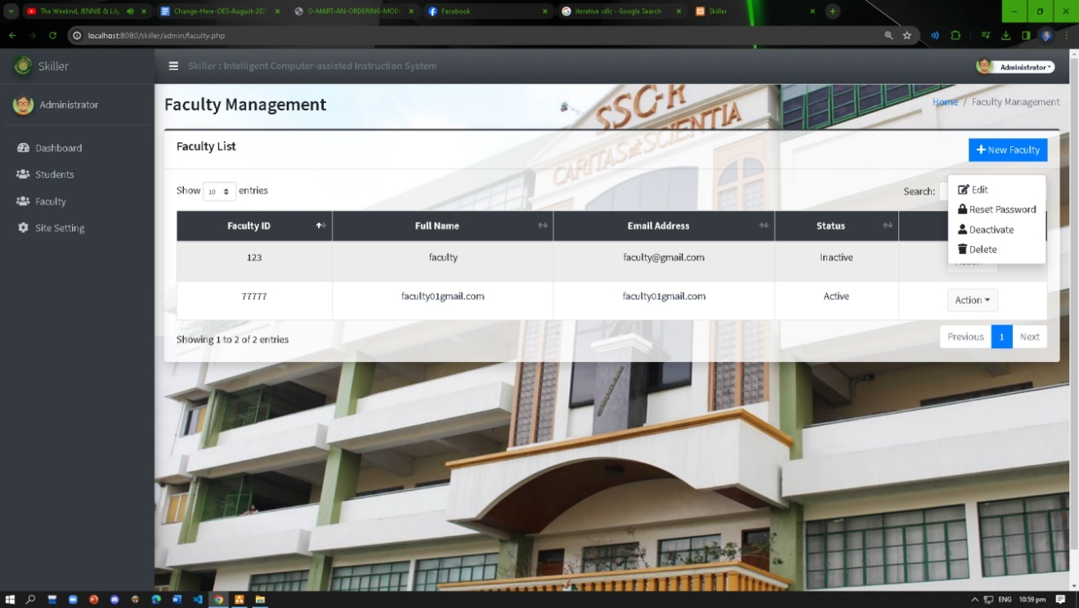

**Figure 10. Admin Faculty Actions**

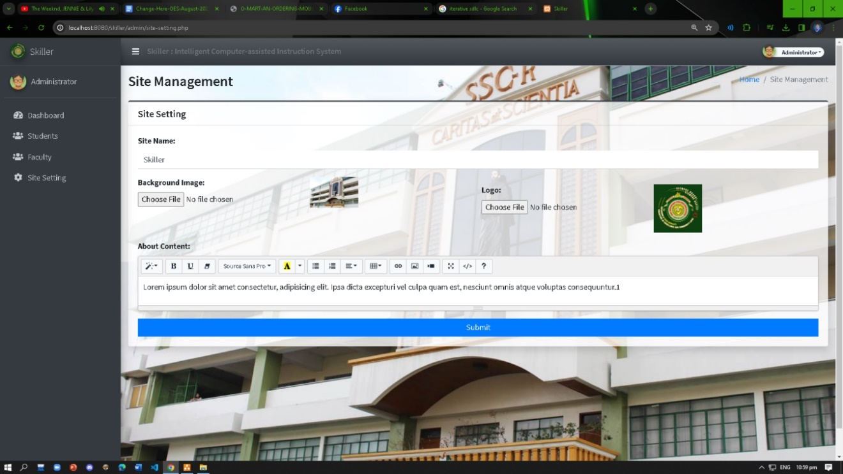

**Figure 11. Admin Site Settings**

**FACULTY PANEL**

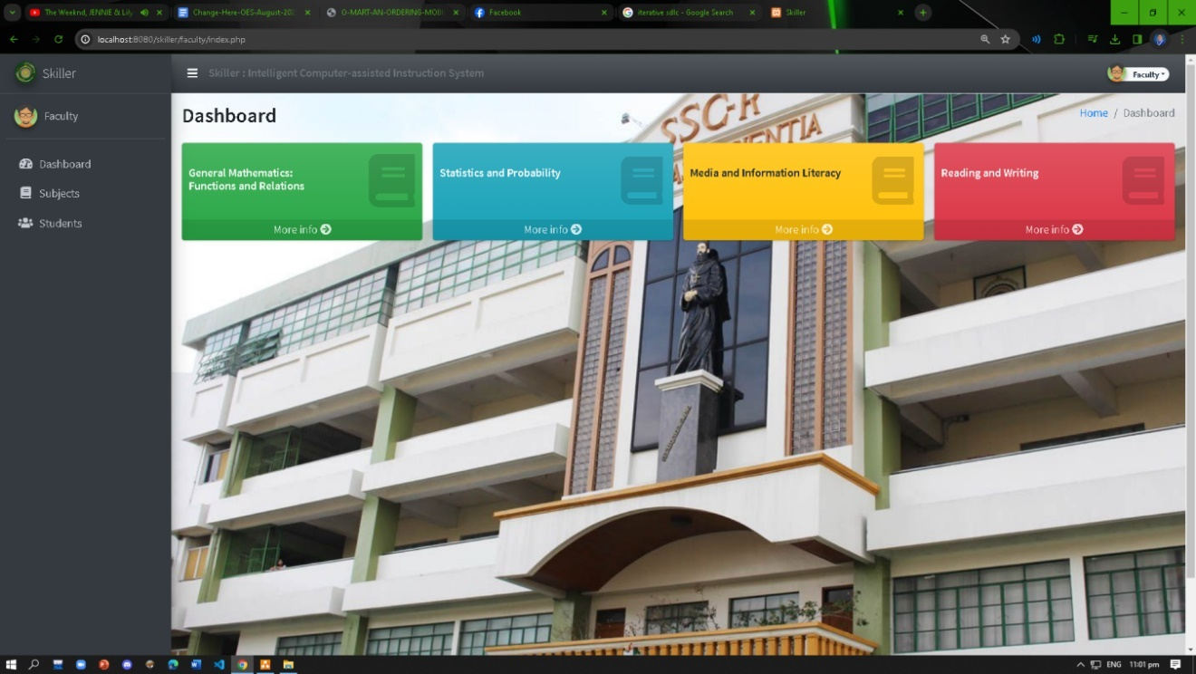

**Figure 12. Faculty Dashboard**

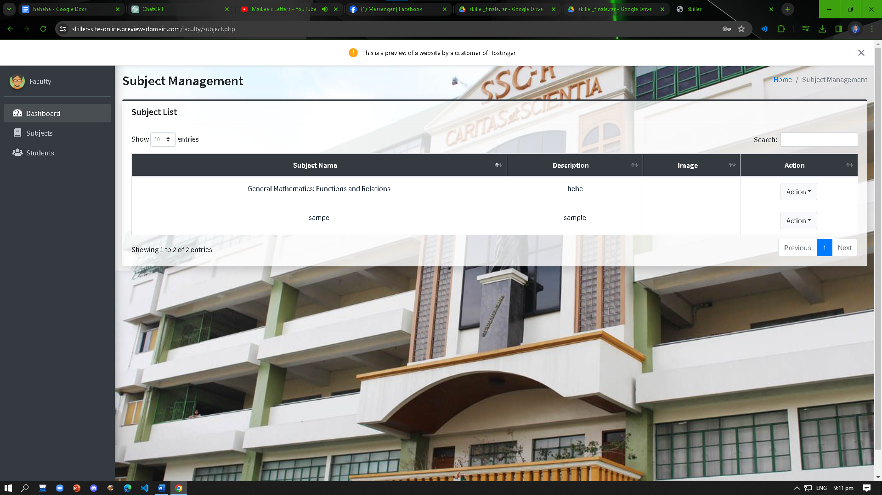

**Figure 13. Faculty Subject**

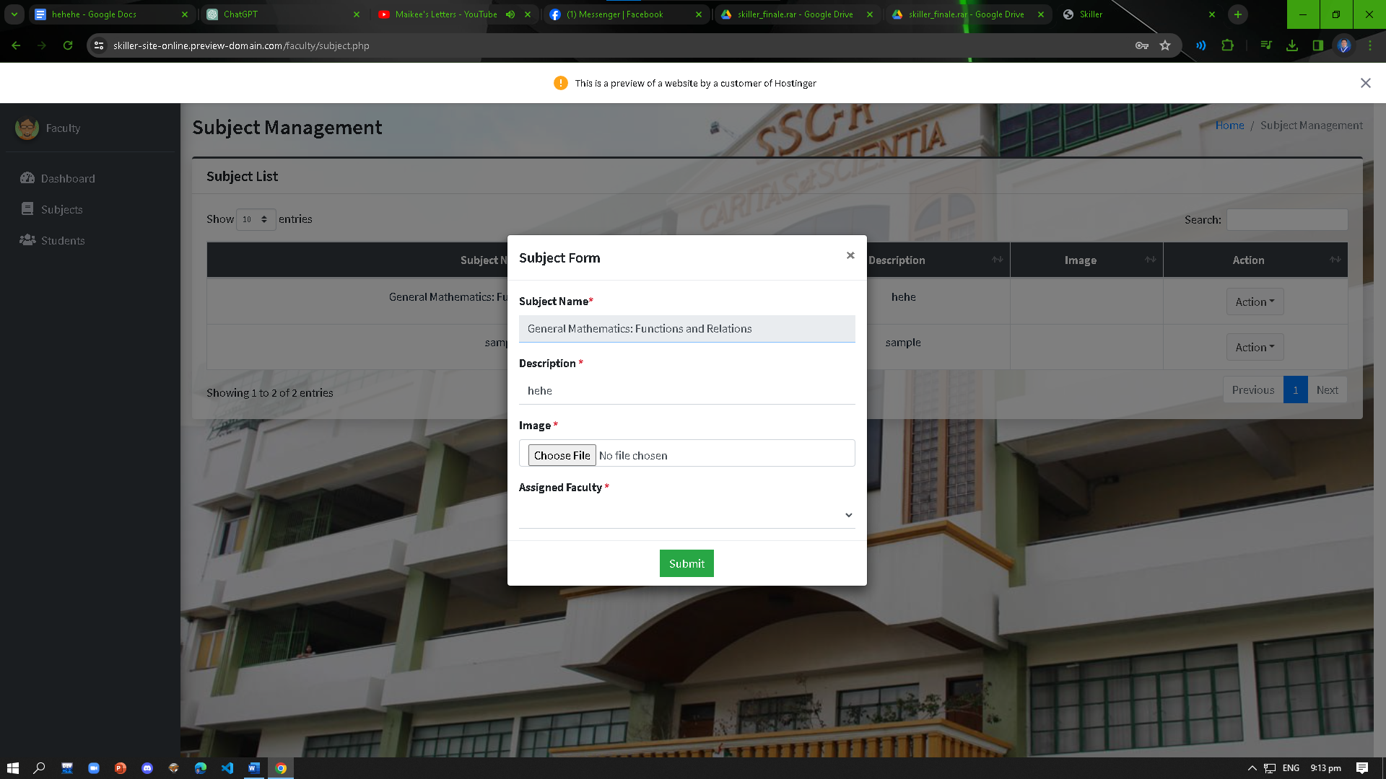

**Figure 14. Faculty Subject Form**

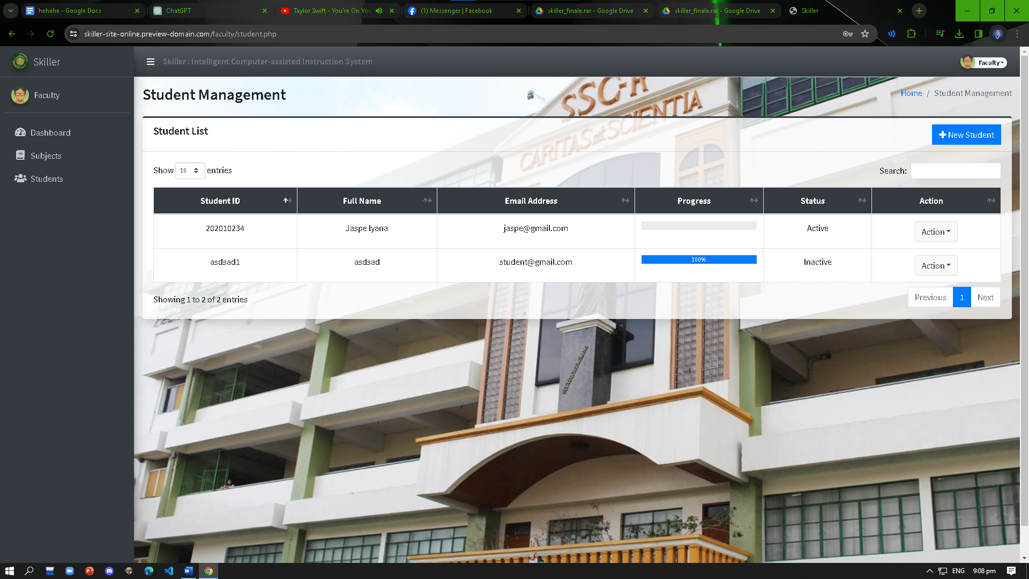

**Figure 15. Faculty Student**

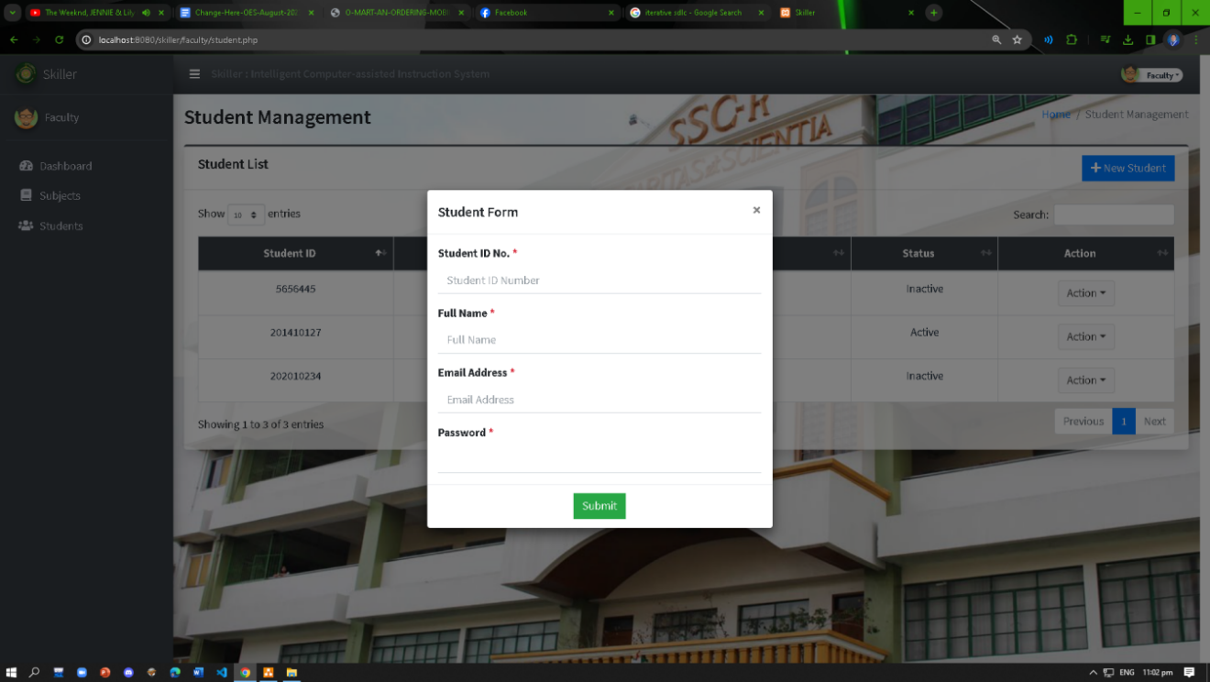

**Figure 16. Faculty Manage Student Form**

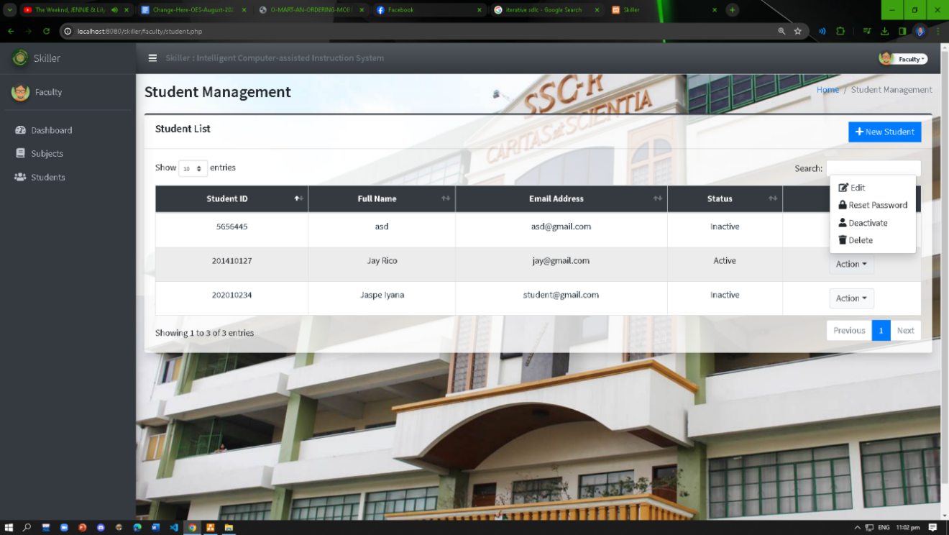

**Figure 17. Faculty Student Action**

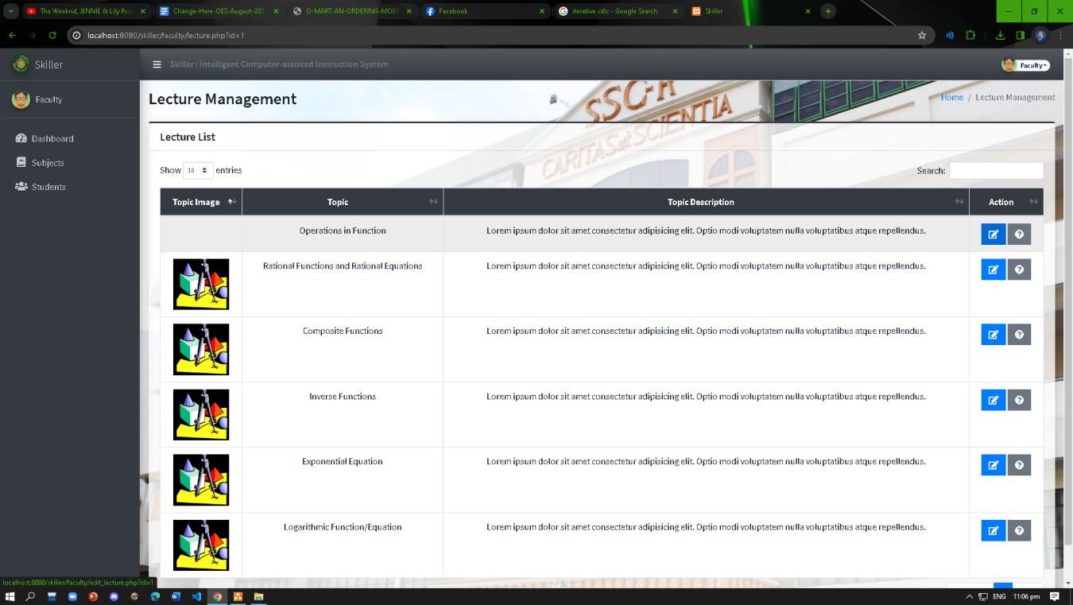

**Figure 18. Faculty Lecture Management**

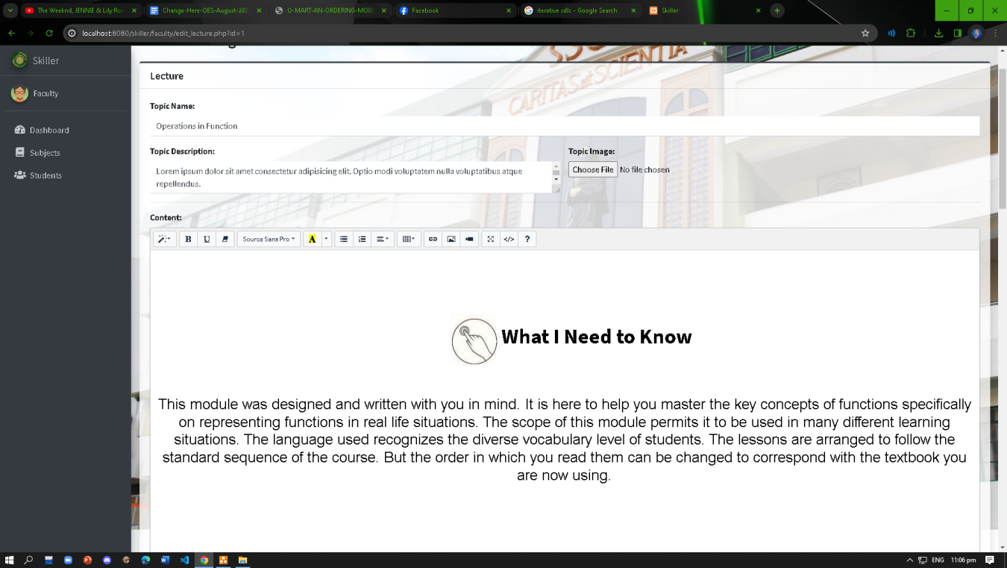

**Figure 19. Faculty Edit Lecture Management I**

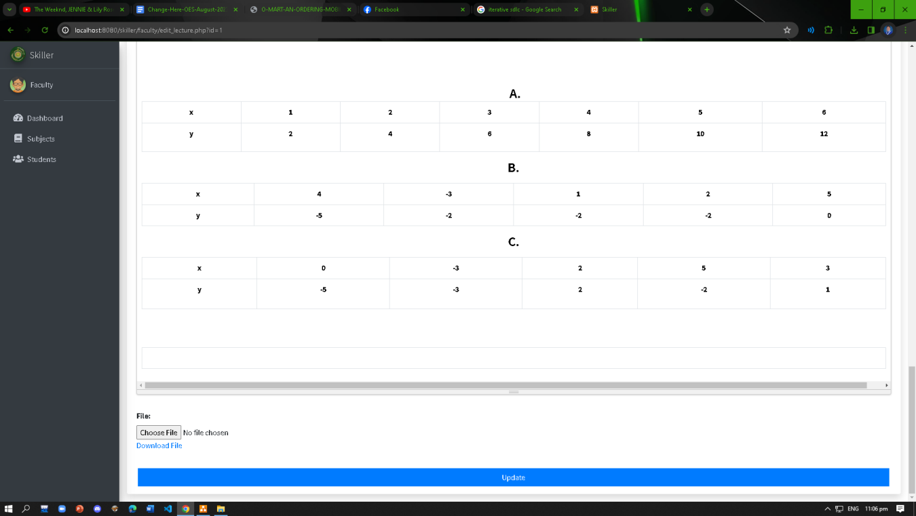

**Figure 20. Faculty Edit Lecture Management II**

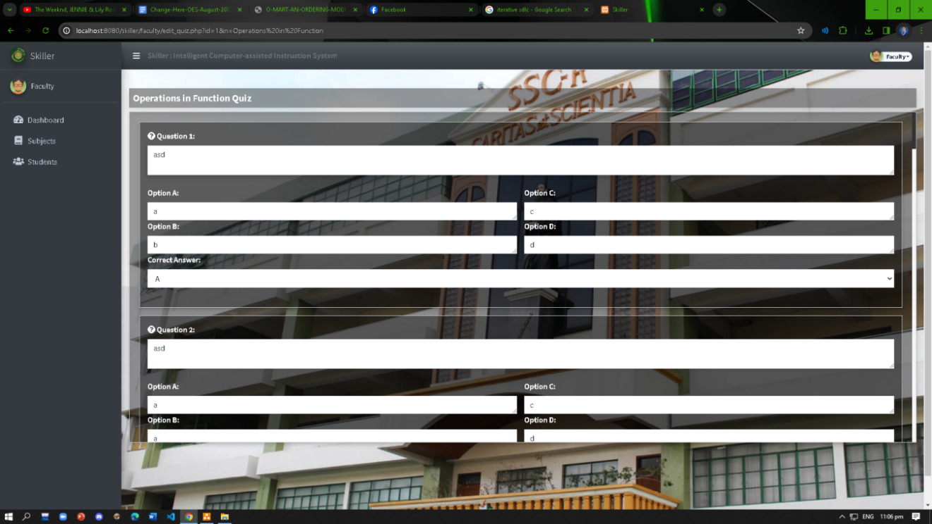

**Figure 21. Faculty Quiz**

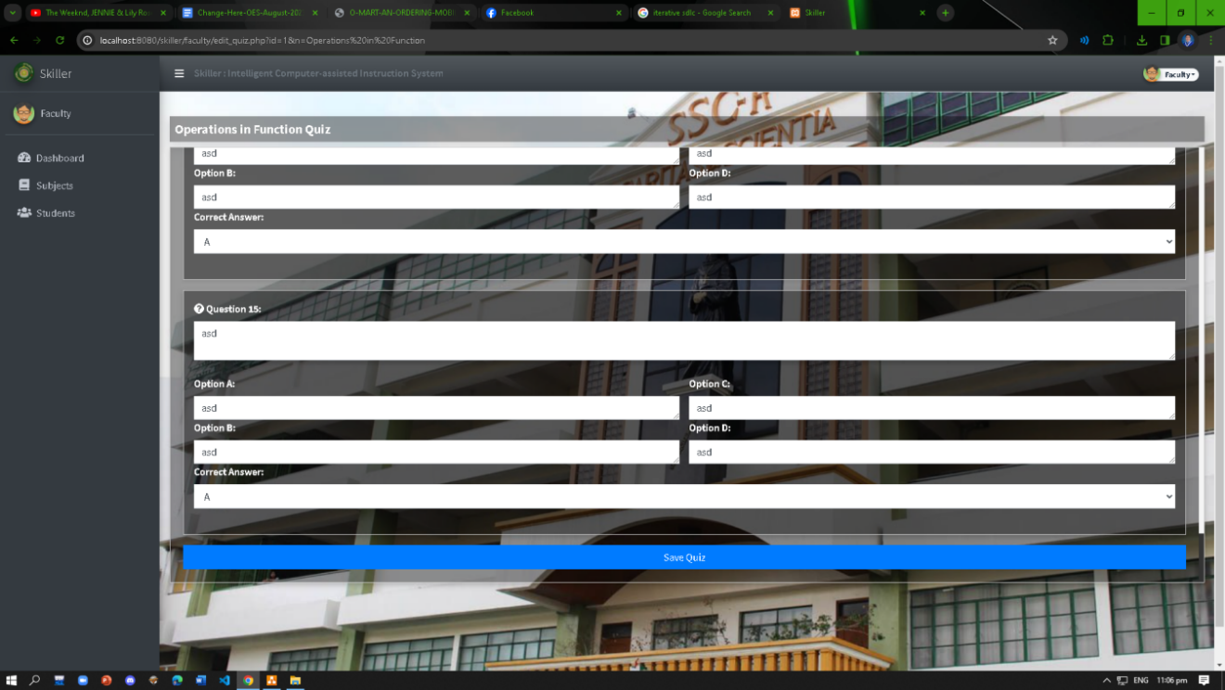

**Figure 22. Faculty Quiz II**

**STUDENT**

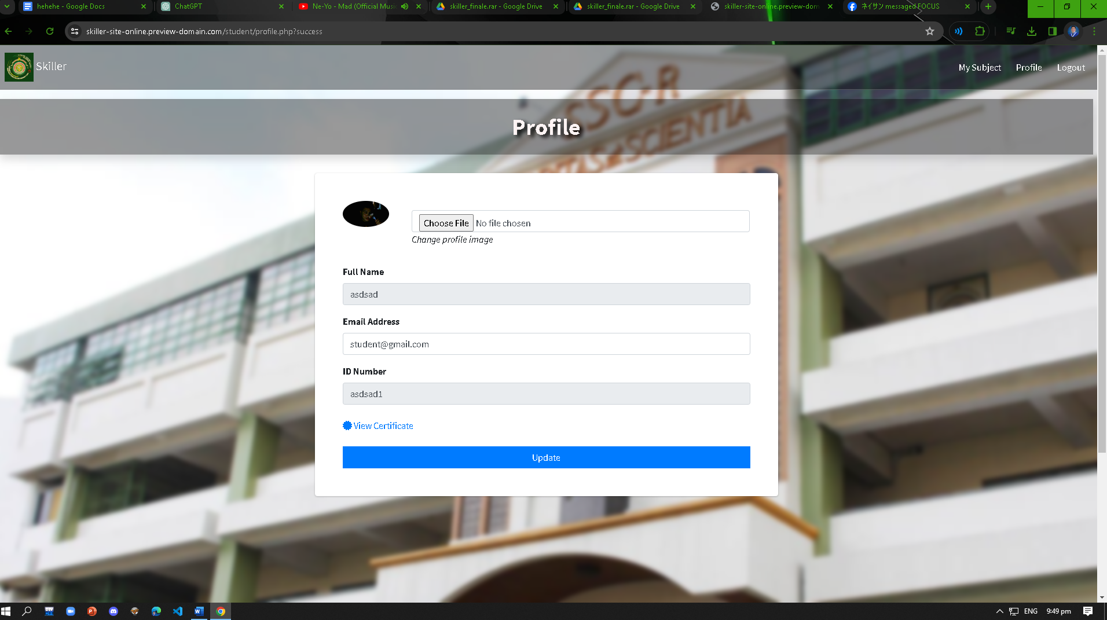

**Figure 23. Student Profile**

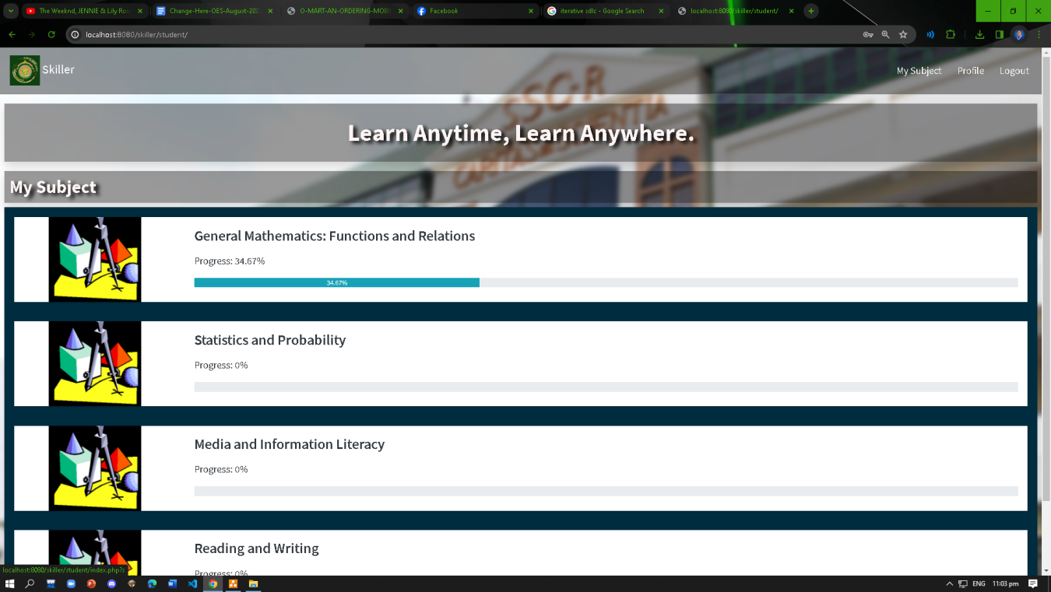

**Figure 24. Student Interface**

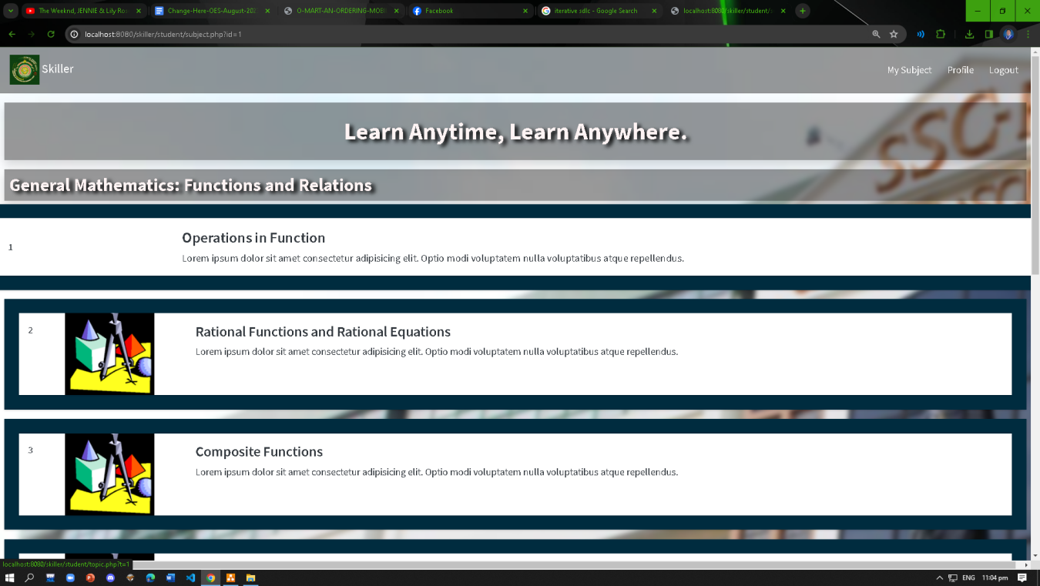

**Figure 25. Student Subject Interface**

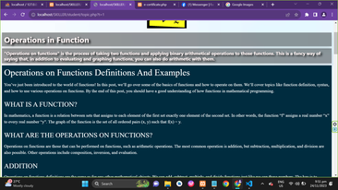

**Figure 26. Student Topic**

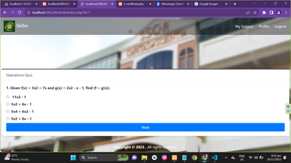

**Figure 27. Student Quiz**

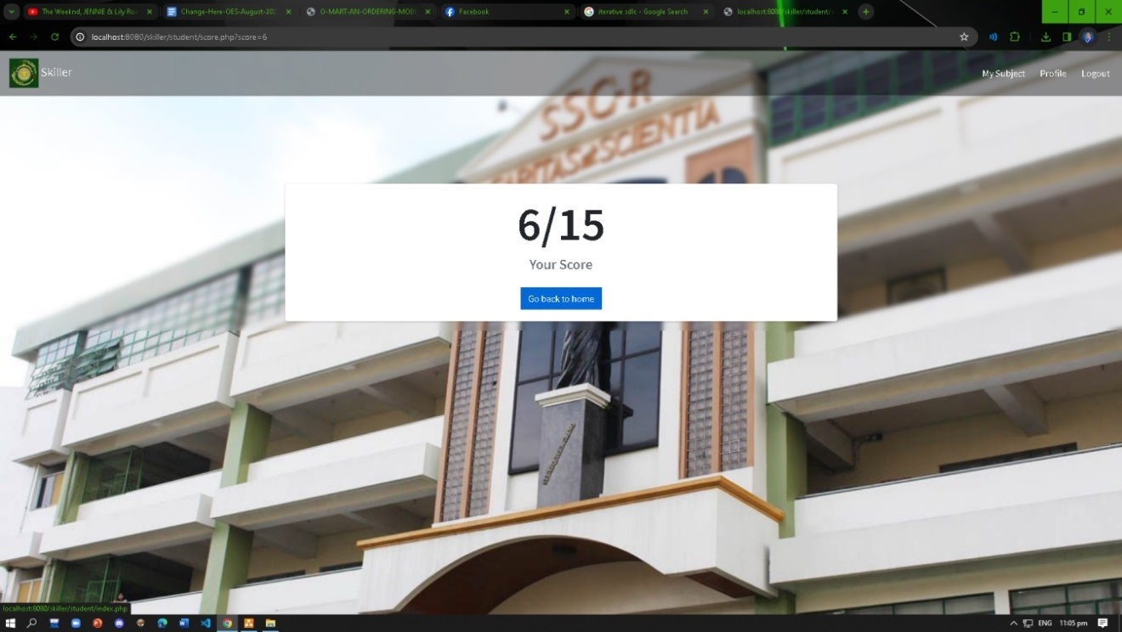

**Figure 28. Student Score Interface**

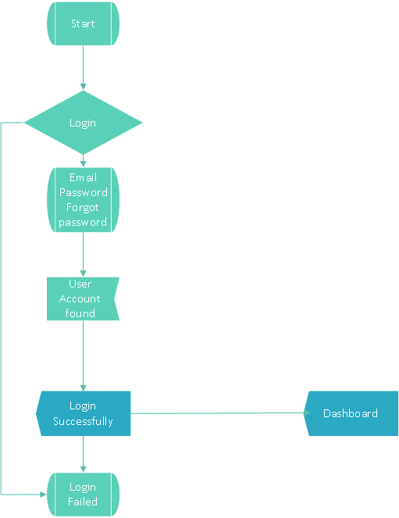

**Login Flowchart**



**Admin Flowchart**

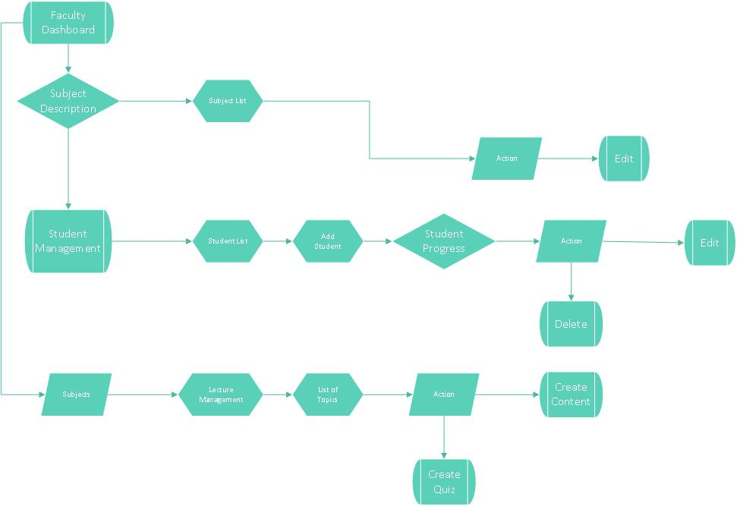

**Faculty Flowchart**

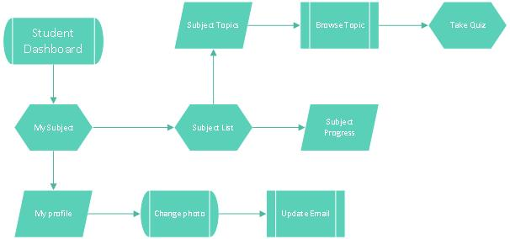

**Student Flowchart**

## Appendix F

**Uml Diagram**

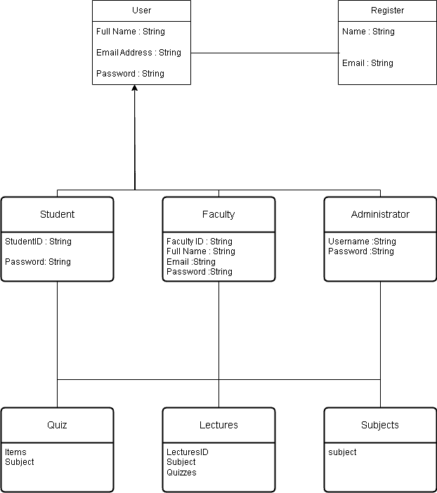

**Class Diagram**

## 

## Appendix G

### Skiller Certificate



## Appendix H

## Data Dictionary

|  |  |  |
| --- | --- | --- |
| **Field Name** | **Data Type** | **Sample Value** |
| **id (PK)** | int | 1 |
| **id_number** | int | 202010234 |
| **name** | text | Jaspe |
| **email** | text | student@gmail.com |
| **password** | text | student |
| **role** | text | Student |
| **otp** | text | 936231 |
| **status** | text | Inactive |
| **image** | text | ../images/Screenshot (4).png |
| **datecreated** | text | 2023-10-17 18:45:30 |

**`tbl_account`**

| **Field Name** | **Data Type** | **Sample Value** |
| --- | --- | --- |
| **id (PK)** | int | 2 |
| **topic_id** | int | 1 |
| **question_id** | int | 2 |
| **question_text** | text | What is x in function and relation |
| **option 1** | text | domain |
| **option 2** | text | range |
| **option 3** | text | y |
| **option 4** | text | x |
| **correction_option** | text | option 1 |

**`tbl_quiz_question**`

| **Field Name** | **Data Type** | **Sample Value** |
| --- | --- | --- |
| **id (PK)** | int | 1 |
| **background** | text | bg.jpg |
| **about** | text | Lorem ipsum dolor sit amet consectetur |
| **site_name** | text | Skiller |
| **banner** | text |  |
| **logo** | text | jpg |

**`tbl_setting`**

| **Field Name** | **Data Type** | **Sample Value** |
| --- | --- | --- |
| **id (PK)** | int | 1 |
| **subject_name** | text | General Mathematics: Functions and Relations |
| **description** | text | Lorem ipsum dolor sit amet consectetur |
| **image** | text | Skiller.jpg |
| **status** | text |  |

**`tbl_subject`**

| **Field Name** | **Data Type** | **Sample Value** |
| --- | --- | --- |
| **id (PK)** | int | 3 |
| **subject_id** | int | 1 |
| **topic_name** | text | Rational Functions and Rational Equations |
| **topic_description** | text | Lorem ipsum dolor sit amet consectetur adipisicing elit. Optio modi voluptatem nulla voluptatibus atque repellendus. |
| **banner** | text | ss.png |
| **content** | text |  |
| **file** | text | irish.docx |
| **date_created** | datetime | 2023-10-17 18:20:35 |

**`tbl_topic`**

| **Field Name** | **Data Type** | **Sample Value** |
| --- | --- | --- |
| **user_answer_id** | int | 220 |
| **user_id** | int | 2 |
| **quiz_id** | int | 1 |
| **question_id** | int | 0 |
| **selected_option** | text | A |
| **date_answered** | datetime | 2023-10-30 08:40:20 |

**`tbl_user_answers`**

| **Field Name** | **Data Type** | **Sample Value** |
| --- | --- | --- |
| **user_score_id** | int | 21 |
| **subject_id** | int | 1 |
| **user_id** | int | 1 |
| **quiz_id** | int | 2 |
| **score** | int | 14 |
| **date_completed** | datetime | 2023-10-30 08:40:20 |

**`tbl_user_scores**

# Appendix I

** Letters**



# 

# 

# Appendix J

**Curriculum Vitae**